
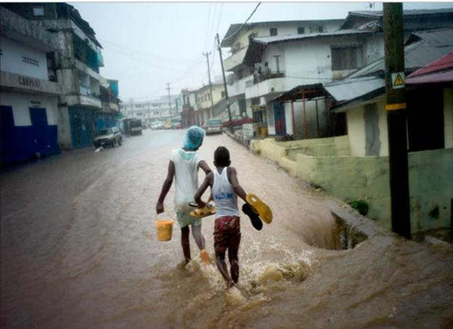

Republic of Liberia

Ministry of Public Works

Liberia Urban Resilience Project
P169718

Stakeholder Engagement Plan

March 2022
Contents
1.0 Executive Summary 4
1.1 Purpose of the Stakeholder Engagement Plan 4
1.2 Objective of the Stakeholder Engagement 5
2.0 Introduction 7
2.1 Country Context 8
2.2 Project Description 10
2.3 Project Development Objective 10
2.4 Project Components 10
2.5 Project Locations & Details 14
2.6. Objective of the SEP 20
3.0 Policy, Regulatory and Institutional Framework 22
3.1 Legal and Policy Framework 22
3.1.1. Liberia’s Legal and Policy Framework 22
3.1.2 The World Bank’s Stakeholder Engagement Requirements 23
3.2 Institutional Framework 24
3.3 Summary of Previous Stakeholder Engagement 26
3.4 Stakeholder Identification and Analysis under the LURP 33
4.0 Methodology 40
4.1 Stakeholder Analysis 42
4.2 Drive and Timing of Stakeholder Engagement Program 43
4.3 Summary of Project Stakeholders Needs and Methods, tools and techniques for stakeholder engagement 43
5.0 Proposed Strategy for Information Disclosure and Engagement Method 50
6.0 Resources and Responsibilities for Implementing the Stakeholder Engagement Activities 54
6.1 Resources 55
6.2 Institutional Arrangements 55
7.0 Grievance Mechanism 56
7.1 Objectives of the GM 56
7.2 Procedures in Grievance Redress 57
7.3 GBV and SEA/SH cases in the GM context 59
7.4 Recommended Grievance Redress Time Frame 59
7.5 Grievance Documentation and Reporting 60
7.6 Reporting on Grievance 61
7.7 The World Bank’s Grievance Redress Service (GRS) 62
7.8 Monitoring 62
7.9 Reporting 63
Annex 1: Grievance Form 64
Annex 2: Stakeholders Met 66

List of Tables
Table 1: Potential project intervention areas 15
Table 2: Brief Description of the Relevant National Acts and Policies to the SEP 22
Table 3: Summary of stakeholder consultation during project preparation (including SEP, ESMF, RPF, preparation) 27
Table 4: Outcomes of Stakeholder Consultative Meeting in county 32
Table 5: List of Affected Stakeholders and Level of Impact 42
Table 6: LURP Stakeholder Engagement Methods 44
Table 7: Summary of stakeholder needs and communication methods 48
Table 8: Information Dissemination and Mode of Disclosure and Engagement for Consultation 51
Table 9: Proposed Budget for SEP Implementation (in USD) 55
Table 10: Proposed GM Time Frame 59

List of Figures
Figure 1: Greater Monrovia area 15

1.0 Executive Summary

Under the Pro-Poor Agenda for Prosperity and Development (PAPD), the current vision and driver for the transformation of the country’s urban development infrastructure agenda has been identified as a key priority. The Government aims to improve the livelihood of communities through measures to ensure they are livable and provides a productive environment that will connect workers to jobs and consumers to markets, thereby increasing opportunities and fueling productivity.
Urban development and disaster risk management are key elements of Liberia’s medium-term national development strategy, and the PAPD. The PAPD (2018-2023) emphasizes the role of urban areas and especially of Greater Monrovia in supporting the economic transformation necessary for the country to generate shared prosperity. The National Disaster Risk Reduction and Resilience Strategy of Liberia (2020) aims to reduce and control the risks associated with flood, coastal erosion and windstorms in the Monrovia area (Action 3.1.).
The Project Development Objective (PDO) of the World Bank financed Liberia Urban Resilience Project (LURP) is to increase flood resilience and access to urban infrastructure in underserved neighborhoods and to improve urban management in Liberia. To meet its development objectives, the proposed US$40.0 million Project will have four components, which are summarized below. The project is coordinating with a French Development Agency (AFD) project of EUR 10.0 million (US$11.2 million) for neighborhood upgrading activities in three neighborhoods: Lakpazee, Shoe Factory and Wood Camp. The AFD financing is parallel financing to the World Bank financing and AFD will develop environmental and social documents applicable to the AFD financing.
This Stakeholder Engagement Plan (SEP) has been prepared by the Ministry of Public Works (MPW) for the LURP. The SEP aims at facilitating stakeholder engagement throughout the Project’s life cycle and across the various project components. This SEP is a ‘living document’ that will be updated and refined by MPW throughout the life cycle of the project.

The SEP will be the operational tool to define the protocols for the effective engagement of the project communities and other stakeholders in overall project development, disseminating activities, outputs and results, coordinate and hold consultations and development of clear channels of communication of the project to all relevant stakeholders and target audience. The SEP will also describe the Grievance Mechanism that will enable effective communication and engagement.

1.1 Purpose of the Stakeholder Engagement Plan
The overall purpose of this SEP is to ensure that a consistent, comprehensive, and coordinated approach is taken to stakeholder engagement and project related information disclosure throughout the project. It is further intended to demonstrate the commitment of the Government of Liberia and the main implementing party, MPW, to an ‘international best practice’ approach to engagement. The LURP is committed to full compliance with Liberia’s Environmental Protection Agency Regulations, as well as aligning with the international standards, namely the World Bank (WB)’s Environmental and Social Standard (ESS10) on Stakeholder Engagement in the context of the World Bank’s Environmental and Social Framework (ESF).
In line with current international best practice, this SEP aims to ensure that stakeholder engagement is conducted on the basis of timely, relevant, and accessible information. In this way, the SEP seeks to ensure that stakeholders are given sufficient opportunity to voice their opinions and concerns, and that these concerns influence project decisions.
The SEP:
- Provides the approach to stakeholder engagement, showing how this will be integrated into the project cycle;
- Identifies the main categories of stakeholders and how they will be included in the project; and
- Identifies the ways to document engagement undertaken throughout the project.

1.2 Objective of the Stakeholder Engagement
The main objectives of SEP include:
- To identify project stakeholders, their priorities, and concerns.
- To identify strategies for information sharing and communication with stakeholders as well as consultation of stakeholders in ways that are meaningful and accessible throughout the project cycle.
- To specify procedures and methodologies for stakeholder consultations, documentation of the proceedings and strategies for feedback.
- To establish an effective, transparent and responsive grievance mechanism for the project.
- To develop a strategy for stakeholder participation in the monitoring of project impacts, documenting, reporting and dissemination of results among the different stakeholders.

This contributes to the SEP’s higher-level objectives of:
- Ensuring Understanding: An open, inclusive, and transparent process of engagement and communication will be undertaken by MPW to ensure that stakeholders are well informed about the proposed development. Information will be disclosed as early and as comprehensively as possible. In order for the stakeholder engagement to be effective, mutual respect, trust, transparent communication between the PMU, GoL and its stakeholders must be maintained throughout the project lifespan. The implementation of the SEP is critical for the success of the project and for the sustainability of the investment in the long term. It will therefore improve decision making and performance by:
- Involving Stakeholders in the Assessment: Stakeholders were included in the scoping of issues, the assessment of impacts, and management/mitigation measures. They also played an important role in providing local knowledge and information for the social baseline and informing the social impact assessment.
- Building Relationships: Through supporting open dialogue, engagement will help to establish and maintain a productive relationship between the MPW and stakeholders. This supported not only an effective SEP, but also will strengthen the future relationships between the Government of Liberia and stakeholders.
- Managing Expectations: It is important to ensure that the LURP does not create, or allow, unrealistic expectations to develop amongst stakeholders about potential Project benefits. The engagement process will serve as a mechanism for understanding and managing stakeholder and community expectations, by disseminating accurate information in an easily understandable manner.
- Ensuring Compliance: The process is designed to ensure compliance with both local regulatory requirements and international best practice;
- Strengthening stakeholder Relations: Allow for a relationship to be built with the various stakeholders of the Project based on mutual respect and trust;
- Disseminate information: Facilitate adequate and timely dissemination of information to the stakeholder groups in a culturally appropriate manner. Provide systems for prior disclosure/dissemination of information and consultation, including seeking inputs from affected persons, incorporation of inputs, as applicable, and providing feedback to affected persons/groups on whether and how the input has been incorporated;
- Establishing Feedback Mechanisms: Providing mechanisms for feedback and dispute resolution;
- Avoiding conflict: understanding current and potential issues such as land rights and proposed project activities
- Identifying, monitoring and reporting on impacts- understanding a project’s impacts on stakeholders, evaluating and reporting back on mechanisms to address these impacts.

Stakeholder engagement shall be informed by clear define principles and core values underpinning interactions with stakeholders. The project will comply with the following;
- Commitment- illustrated when the importance of understanding, engaging, identifying the stakeholders is recognized and acting upon earlier on during the project.
- Integrity – is conducted when the engagement fosters mutual respect and trust;
- Respect- is created when the rights, religious belief, cultural beliefs, values and interests of the stakeholders and affected communities are recognized:
- Transparency- is demonstrated when the communities’ concerns are responded to effectively and efficiently.
- Inclusiveness- achieved when broad participation is encouraged and supported by appropriate participation opportunities, and
- Trust – achieved through open and meaningful dialogue that respects and upholds a community’s beliefs, values and opinions.

2.0 Introduction
The Government of Liberia (GoL) is in discussions with the World Bank (WB) to enhance urban living conditions and climate resilience in Greater Monrovia and across Liberia, and to strengthen municipal and institutional capacities for integrated urban management. The GOL, through the MPW shall implement material measures and actions so that the Project is implemented in accordance with the World Bank Environmental and Social Standards (ESSs). The GoL shall also comply with the provisions of any other E&S documents required under the ESF and referred to in this SEP, such as the Environmental and Social Management Framework (ESMF), Environmental and Social Management Plans (ESMP), Resettlement Policy Framework (RPF), Resettlement Action Plan (RAP), Livelihood Restoration Plan (LRP), Grievance Mechanism (GM), and the timelines specified in those E&S documents.
This document presents the SEP for the proposed Liberia Urban Resilience Project (LURP), to be implemented by the MPW. The document has been prepared, with the aim of guiding the stakeholder consultation and grievance redressal processes across the life of the Project. The main purpose of this plan is to allow the stakeholder engagement to be undertaken in a systematic manner that will allow the various stakeholder groups to express their individual views and opinions, and the Project to appropriately respond to them. The plan is aimed at enabling active meaningful engagement with the stakeholder groups by identifying different mechanisms for the participation of stakeholder groups, especially vulnerable groups.

The Project, which has the following four basic components, will enhance urban living conditions and climate resilience in Liberia, and will strengthen institutional capacity for sustainable urban management. The project components include:
- Component 1: Climate Resilient Infrastructure and Urban Upgrading
- Component 2: Strengthening Integrated Resilient Urban Development Capacity
- Component 3: Project Management
- Component 4: Contingency Emergency Response Component
This SEP is designed to establish an effective platform for productive interaction with potentially affected parties and persons with interest in the implementation and outcomes of the Liberia Urban Resilience Project (LURP). It identifies the major stakeholders affected by the project either directly or indirectly (including vulnerable groups) as well as those with other interests that could influence decisions about the project. It outlines previous stakeholder engagement efforts carried out as part of the preparation of the project and articulates a range of strategies for timely, relevant and accessible stakeholder engagement throughout implementation. The SEP is also prepared in compliance with the application of the World Bank Environmental and Social Standard 10 on Stakeholder Engagement and Information Disclosure.
Based on the planned subproject interventions, the project environmental and social risks have been assessed as substantial. The potential environmental and social risks and impacts have been identified and mitigation measures proposed in the Environmental and Social Management Framework (ESMF) and Resettlement Framework prepared for the project. Stakeholder groups identified under the project include individual beneficiaries, communities, private sector entities, Contractors, Training Service Providers, government agencies, municipality leaders, Civil Society Organizations (CSOs), Non-Governmental Organizations (NGOs), Academia and Research Institutes. Vulnerable groups identified include persons with disabilities, women, youth, etc.
Strategies for engaging stakeholders identified in this SEP include use of both traditional and modern media communication channels such as community sensitization meetings, websites, printed media, information center boards, community meetings, office to office meetings, especially with government agencies, newsletters, brochures, fact sheets, and conduct of periodic surveys/citizen’s engagement. Follow-up on grievances and actions taken will form part of the overall monitoring of the project. Furthermore, various strategies for involving stakeholders in project monitoring and reporting have been identified. Resources and implementation arrangements for SEP activities will be covered under Component 3 (Project Management).

2.1 Country Context
Liberia’s basic infrastructure and social services were severely affected by the Liberian civil war which lasted about 14 years; the recovery efforts from post war era was further hamper by the recent Ebola virus epidemic of 2014, resulting in poor living conditions for most of the population and eroding some of the economic gains after the war. A gross national income per capita of just US$580 in 2019 places Liberia among the ten poorest countries in the world. According to the 2016 household survey data, over half of the population (51 percent) was living in poverty. The country still faces numerous challenges including environmental degradation, susceptibility to disease and epidemics, exposure to multiple natural disasters, severe deficits in basic service delivery, a highly resource-constrained environment, lagging nutrition and health outcomes, food insecurity, and an economy unable to create sufficient jobs. Liberia’s economy is now facing the impacts of the COVID-19 pandemic and Greater Monrovia could play an important role in supporting the economic transformation necessary for the country to recover from the COVID-19 pandemic and to build back better.

When cities function well, they create a livable and productive environment that connects workers to jobs and consumers to markets, thereby increasing opportunities and fueling productivity. Greater Monrovia is the largest agglomeration in Liberia, but decades of conflict has stalled investments and development. Greater Monrovia is home to about 1.5 million people, a fourth of the country’s total population. The growth rate of Monrovia is 4.46 percent annually. It is projected that 70 percent of Liberia’s total population will be living in urban areas by 2030. Climate-related hazards are negatively affecting the country’s economy and its population in general and the Greater Monrovia area in particular. Liberia receives a high rainfall, especially along the coast, and Monrovia is the wettest capital of the world with a yearly average of more than 5 meters. Severe rainfall events occur during the rainy season resulting in localized floods across the country.
Monrovia’s drainage system is fragmented and insufficient. Monrovia’s surface water system was constructed between 1955-1957 with later additions to accommodate urban growth. In Central Monrovia, parts of Sinkor and Bushrod Island, most of the roadside drains consist of closed culverts, taking the storm water through gutters. In lower density areas, the drains are mostly open, following natural creeks. The system is plagued by several challenges, including lack of maintenance (only 15 employees of the MPW are working on surface water drainage in Monrovia), inadequate drainage construction and connection to sewers, illegal connections of sewage pipes to drains, and lack of funding.
Inadequate sanitation systems in Greater Monrovia increase communities’ health risk and contribute to environmental pollution, especially during flood events. Most of the sewer network in Greater Monrovia is blocked and often overflowing, leading to the use of alternative means of wastewater disposal. For facilities such as septic tanks, the lack of a safe final disposal site leads to uncontrolled environmental pollution and associated health risks. Inadequate infrastructure and flood risks combined with management deficiencies negatively affect the resilience, economic activity, and revenue potentials of markets in Greater Monrovia. Duala market is one of Monrovia’s biggest markets and is illustrative for the challenges faced by Monrovia’s markets. Duala market has expanded 11.8 times in size without any planning since its creation. Therefore, Duala market suffers from a fragmented and ineffective drainage system
Primary and secondary cities in Liberia suffer similar challenges to those in Greater Monrovia, however, at a smaller scale. The civil war damaged much of Liberia’s infrastructure. Facilities still intact have deteriorated due to poor maintenance. Urban growth rates continue to over-burden infrastructure and demand for basic services. Capacity to provide infrastructure and basic services for densely populated urban centers is limited given the inability of municipalities to plan and prepare for urban growth. As a result, secondary cities are facing significant infrastructure related challenges related to transportation, water, sanitation, and hygiene (WASH), solid waste management, electricity, and digital infrastructure. Outside of Greater Monrovia there is no government piped water and sewage system, no secondary roads are paved and there are no engineered drainage systems. In terms of connectivity, cities in the North Central region do not have adequate road connectivity between primary and secondary cities. Ninety percent of the total Liberian population live within a 2-hour commuting distance from a large city, those who live beyond the range of the Monrovia-Ganta Corridor are faced with challenges regarding market accessibility. In Gbarnga, 17 percent to 35 percent of the roads are in adequate condition and further north in Voinjama less than 16 percent of the roads are in good condition. There is inadequate infrastructure and limited services to enable access to safe drinking water in all communities. It is estimated that 90 percent of the Liberian population does not have access to safe drinking water. Sanitation is inadequate due to insufficient and damaged sanitation infrastructure, resulting in open defecation and urination. According to the Joint Monitoring Programme in 2017 about 42 percent of the Liberian population practices open defecation (JMP, 2017). Secondary cities have no capacity to manage solid waste. Local government authorities have admitted to gaps in maintaining waste management operations due to financial and human capacity constraints. They estimate that only 15 percent of the population have access to waste collection disposal facilities. Many households in secondary cities depend on firewood and charcoal for cooking and heating, while palm oil, kerosene and candles are used for lighting. In 2016 68.8 percent of urban homes in Liberia did not have access to electricity. There are 2 private mobile companies and 1 national public corporation currently providing digital infrastructure in Liberia. In 2016, with internet service in the North Central region, 43 percent of households received money transfers and 33 percent sent transfers.
Lack of planning capacities and enforcement of planning, zoning and building control exacerbates flood risks and contributes to proliferation of informal settlements and addressing urban resilience requires addressing gender gaps. A recent gender assessment of Monrovia concluded that women’s political participation at the municipal level and decision-making structures is low. The lack of involvement of women exacerbates existing gender gaps, such as women’s limited access to safe, affordable, accessible infrastructure or gender-blind infrastructure design that doesn’t consider and address women’s needs.

2.2 Project Description

Liberia’s urban development challenges and flood risks provide a strategic opportunity to implement a cross-cutting approach that concurrently enables the delivery of basic services, reduces food risks, and increases capacities for the future management of Greater Monrovia and across Liberia. In response, this project is designed to a) mitigate flood risks through structural and non-structural measures; b) provide services/infrastructure investments in underserved neighborhoods; and c) improve institutional capacity for urban planning and management.

2.3 Project Development Objective
The Project Development Objective (PDO) is to increase flood resilience and access to urban infrastructure in underserved neighborhoods and to improve urban management in Liberia. To meet its development objectives, the proposed US$40.0 million Project will have four components, which are summarized in the table below. In addition to the IDA financing, the French Development Agency (AFD) will provide parallel financing in the amount of EUR10.0 million (US$11.2 million) for neighborhood upgrading activities, for which AFD will prepare its own environmental and social frameworks and instruments.

2.4 Project Components

Project Components
 |  | IDA Financing
Component 1 | Climate Resilient Infrastructure and Urban Upgrading | $30 million
Component 2 | Strengthening Integrated Resilient Urban Development Capacity | $6 million
Component 3 | Project Management | $4 million
Component 4 | Contingency Emergency Response Component | $0 million
Total |  | $40.0 million

Component 1: Climate Resilient Infrastructure and Urban Upgrading
This component will support flood risk management and community upgrading infrastructure in prioritized areas of Greater Monrovia. Investments in drainage infrastructure will improve connectivity of drainage networks and are prioritized to reduce climate and flood risk. Associated neighborhood and market upgrading interventions will improve living and working conditions and access to public services. This component will finance (i) feasibility and design, (ii) consultations, (iii) environmental and social framework (ESF) studies and instruments, (iv) compensation payments for resettlement, (v) works, (vi) supervision, and (vii) servicing and maintenance contracts. A waiver for IDA payment of resettlement compensation will be proposed, based on a desk-based estimation of the compensation costs, in the absence of design footprint and site-specific Resettlement Action Plans (RAPs).

Four key areas are being considered, based on their climate vulnerability, government priorities, economic significance, balance between MCC and PCC and consideration of other ongoing donor investments. The prioritization of these areas and associated investments in these areas will be confirmed through a feasibility study. The selected areas of intervention include: a) Northern Bushrod Island, including Duala market (MCC), b) Central Monrovia – Soniwein drainage system (MCC), b) Omega Market Area (PCC), and d) South Eastern Paynesville, Duport Road area (PCC). Selection criteria are based on flood risk. A feasibility study will be completed to define the scope of interventions. Annex 2 provides a detailed description of the proposed areas and possible interventions to be financed under Component 1.

Subcomponent 1.1: Climate and Flood Risk Management Infrastructure. This subcomponent will support climate and flood risk management in prioritized areas of Greater Monrovia. It will finance rehabilitation of existing and construction of new drainage infrastructure in selected areas. The rehabilitation of drainage systems will include the cleaning of surface and underground channels as well as the repair of surface and underground channels as needed. This will be complemented with new blue-green-grey drainage measures, including blue solutions (open water areas for temporary stormwater storage), green solutions (wetland or green vegetated areas to maintain soil infiltration and temporarily store surface stormwater), and grey solutions (traditional constructed drainage of adequate size and design to drain roads, residential areas and markets). The infrastructure will be designed with climate resilience in mind, so that 10 year floods under the most likely 2050 climate scenario will be anticipated and designed for. Designs will also consider opportunities to minimize operations and maintenance needs and costs due to limited government capacity.

Subcomponent 1.2: Climate Resilient Community and Market Upgrading. This will finance community infrastructure investments in neighborhoods and market areas in the same locations as the drainage and water retention infrastructure. Infrastructure will be prioritized based on consultation with community and market representatives to prioritize investments. Infrastructure investments could include improved water supply, sanitation and waste management/transfer/sorting facilities, community halls, childcare and health facilities, cold storage facilities, and green parks and recreational spaces. Investments will be based on resilient design principles by using, e.g., energy efficient lighting and equipment, solar panels, roof top greenery, measures/design principles that reduce the need for air-conditioning, elevated construction to protect against flood risk, more resilient building materials, etc. The project will ensure that women are engaged in the envisaged participatory, community-led decision-making processes such that their needs and safety concerns will inform the proposed urban design and infrastructure interventions.

Component 2: Strengthening Integrated Resilient Urban Development Capacity

Beyond Greater Monrovia, urban centers across the country are growing rapidly, and while they do not face the same intensity of urban challenges due to their much smaller populations, support to effectively plan urban growth and associated infrastructure and service delivery needs, can help these cities to avoid some of the challenges that Greater Monrovia now faces. This Component will therefore support resilient integrated spatial planning, capacity needs assessment and investment plans in Greater Monrovia, including Paynesville, as well as the next three largest cities in Liberia, Buchanan, Gbarnga and Ganta. It will also provide dedicated capacity building of municipalities and other institutions associated with resilient urban development and solid waste management. Capacity building activities are intended to contribute to better resilient planning and development control, integrating gender-informed urban design, increasing fiscal space, and improved coordination.
Subcomponent 2.1: Resilient Urban Planning and Development Control. This subcomponent will finance activities to increase the capacities of relevant stakeholders to develop, maintain and update a climate resilient spatial development plan. The plan would be developed through a participatory process involving intensive stakeholder engagement, and the output would emphasize the spatial elements needed to guide climate resilient infrastructure investments and land use in Greater Monrovia and safeguarding against development on land most vulnerable to climate and flood risk. The plan will also include an infrastructure diagnostic and investment plan, including transport, drainage, ICT, water and sanitation, and market infrastructure. To oversee the development of the proposed plan, the project will finance operational expenses of a Greater Monrovia Task Force. Similar plans and task forces will be developed for Buchanan, Gbarnga and Ganta. Further, in order to connect the Greater Monrovia metropolitan scale plan to local communities, this subcomponent will support the development of detailed local area plans for at least two target neighborhoods adjacent to Component 1 infrastructure investments.
In order to support the effective implementation of such planning instruments, this subcomponent will also support an urban development control strengthening program which will (i) assess opportunities for strengthening the existing legal framework, institutional arrangements, and current practices; (ii) develop a comprehensive national training and skills development needs assessment for urban planning, management and land administration and implementation of relevant trainings; (iii) prepare development control tools, including digitization of permitting systems; and (iv) deliver targeted training to civil servants and appointed officials at the central and local government level with the possible inclusion of community-level organizations. This sub-component is being supported by a WB-executed technical assistance project conducting a Building Regulatory Capacity Assessment, whose results will help to inform the design and activities under this sub-component in more detail. Ultimately, the strengthening of urban development control systems and practices, using climate risk maps to inform no-build zones, paired with a public awareness campaign on climate risks also to be supported under the program, is anticipated to contribute to a reduction of citizens settling in high climate and flood-risk zones or ecologically sensitive areas, thereby reducing climate risk in the medium to long term.
Subcomponent 2.2: Solid Waste Management Operations and Financing. To keep drainage and other hydraulic infrastructure clear of waste, allowing for the infrastructure to effectively protect against climate and flood risks, the Solid Waste Management (SWM) system, which is a core responsibility of municipal governments, needs to be drastically improved. This subcomponent will therefore finance the development of a Solid Waste Management Operational Plan for the Greater Monrovia Area that will include a detailed financial model, private sector engagement plan and inform the operational needs of the system. The plan will also lay out contractual options to combine SWM collection with regular drainage clean-up operations, since drains are acting as waste receptacles in Greater Monrovia. The strategy will build on the revenue-oriented elements of the Local Government Act and include a diagnostic and needs assessment of current local government revenue mobilization and identify an action plan to enhance revenue streams. This component will build on the achievements of the Cheesemanburg Landfill and Urban Sanitation (CLUS) project and recent sectoral diagnostic work of Cities Alliance in close coordination with MCC and PCC. In addition, since CLUS is reaching the end of its project lifespan and resources, some activities that may not be completed under that project could be taken up, such as the feasibility, design and ESF studies for SWM facilities. Equipment and capacity development needs to enhance revenue mobilization and collection will also be supported. Similar SWM planning and capacity support will be offered to Buchanan, Gbarnga and Ganta. The sub-component will build on the technical assistance provided under the Bank Executed Pro Blue project

Component 3: Project Management
This component would finance the Project Management Unit (PMU) activities related to project coordination, safeguards implementation, M&E, procurement, etc. Operational costs to support efficient management of the project would be included.

Component 4: Contingency Emergency Response Component (CERC)
The CERC is a zero-sum component included to mitigate situations of urgent need and allows for the rapid reallocation of funding in the event of a natural disaster or crisis that has caused, or is likely to imminently cause, a major adverse economic and/or social impact.

2.5 Project Locations & Details

Under Component 1, the project will finance (i) rehabilitation of existing and implementation of new drainage infrastructure in the selected areas, (ii) the cleaning of surface and underground channels by removal of sludge, silt, organic material, and debris, (iii) the repair of surface and underground channels, including the replacement of broken or missing manhole covers. Where necessary, this will be complemented with new blue-green-grey drainage measures, including blue solutions (open water areas for temporary stormwater storage), green solutions (wetland or green vegetated areas to maintain soil infiltration and temporarily store surface stormwater), and grey solutions (traditional constructed drainage of adequate size and design to drain roads and residential areas). (iv) several measures with traditional concrete drains conveying water towards rehabilitated/protected urban wetlands and permeable paving to enhance infiltration or green swales (vegetated strips that capture and store stormwater from roads and residential areas). Such measures will be combined with improved land use planning, zoning and construction permitting (see below).
Apart from access and drainage investments the activities may also include other secondary and tertiary infrastructure for markets and communities such as water supply, sanitation (wastewater and solid waste collection facilities) and community facilities such as community halls, open spaces, playgrounds etc. Many of these facilities should consider the functional rehabilitation of underutilized spaces where feasible. Project investments would complement existing/ongoing World Bank financed projects in related sectors either through working in neighborhoods where no network services are in place or by focusing on upgrading reticulation/neighborhood systems where there is access to network services. The specific investments will depend on the feasibility studies, which will also ensure that gender gaps will be identified and addressed through the investments, for example ensuring that sanitation facilities are safe for women.
Component 1 will be implemented in the Greater Monrovia Area, which can be seen in Figure 1.

Figure 1: Greater Monrovia area (Sources: Borders, Administrative divisions: GDAL, LIZ-GIS / Places: MSF, Geonames, HOT-OSM / Roads, Natural: HOT-OSM / Other data: MSF)
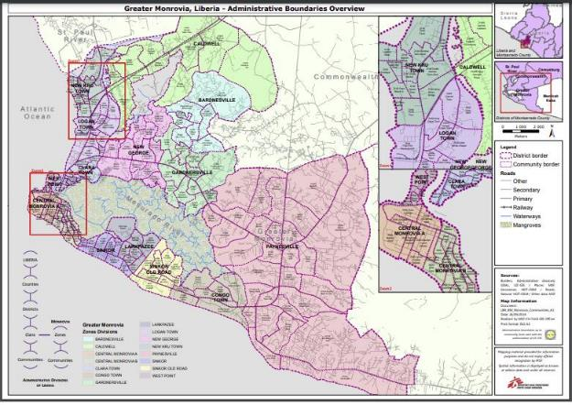
Four main locations are described in Table 1 within Greater Monrovia are being considered for this intervention, which requires further feasibility assessment to determine the economic, technical, environmental and social viability of this work.
Table 1: Potential project intervention areas
Area 1: Northern area of Bushrod Island
The area is underserved regarding drainage infrastructure and frequent flooding occurs around the Duala market and in other urbanized parts mainly as a result of pluvial events. The northern and eastern part is also vulnerable to fluvial and coastal flooding. Envisioned urgent structural interventions in this area are at this moment: i) road drainage along the northern part of UN Drive (currently non-existent), ii) enhance connectivity of runoff from the urbanized areas to the low-lying and open spaces on the east and west part of island; iii) preserve and connect the open greens areas as retention areas for (future) rainfall events, iv) improve connections towards the north (St Paul River mouth) and/or east (Stockton Creek). For coastal and fluvial flood risk, this assignment should further analyze during the initial stage if these risks can be mitigated with structural solutions in an effective way and if these should be prioritized over pluvial drainage infrastructure interventions. The drainage interventions can be accompanied with some urban upgrading interventions to be defined further in a detailed feasibility and design study.
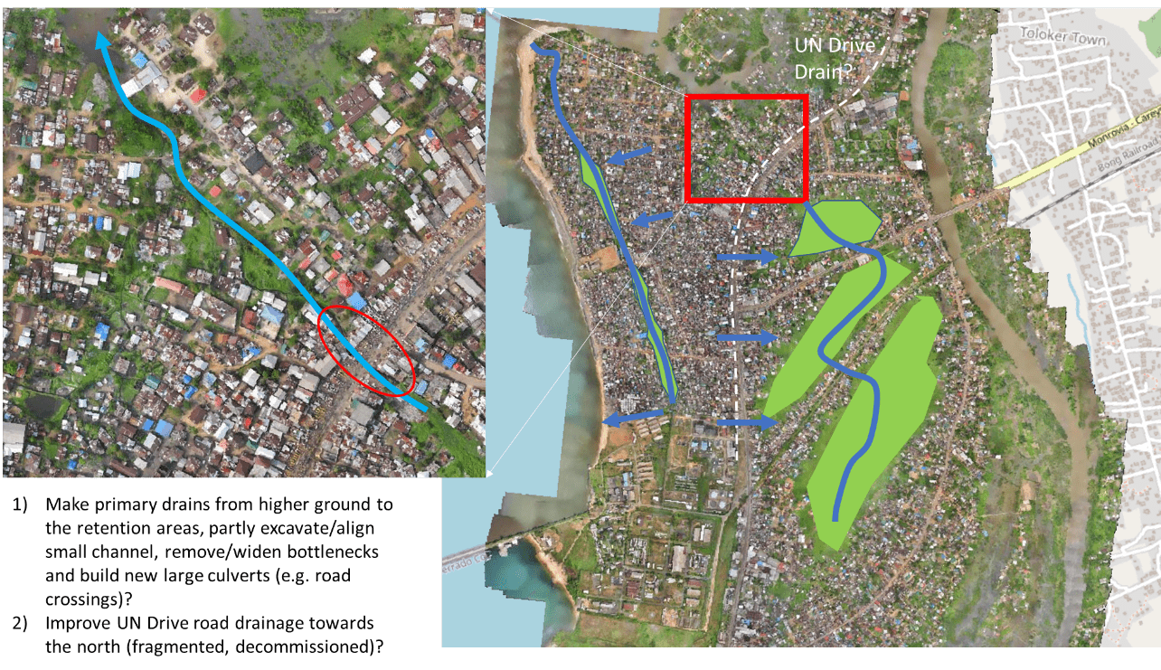
Area 2: Omega Market area
This area is located under the jurisdiction of the Paynesville City Council (PCC) and the Omega Market is located at the location of the former Paynesville Transmission Tower. The Omega Market was opened in 2016 and further expansion of the market is considered. The Omega Market area, however, faces significant flood issues during pluvial rainfall events. Based on an initial analysis of the topography and modeling, this relatively flat area collects rainwater from the surrounding elevated areas before draining further towards the southeast into the Mesurado River. Potential bottlenecks for sufficient drainage are: i) insufficient secondary/tertiary infrastructure surrounding the built-up area including Omega Market, ii) insufficient storage/retention area, and iii) insufficient conveyance capacity of the stream towards Mesurado River due to a limited and vegetated cross-section, road crossings, or a combination of the above. Prioritizing these bottlenecks and identifying and designing structural solutions to resolve these will be part of the feasibility studies to define a set of prioritized interventions for this area. These drainage interventions could be combined with some urban upgrading investments (e.g., public amenities, urban parc development, etc.).
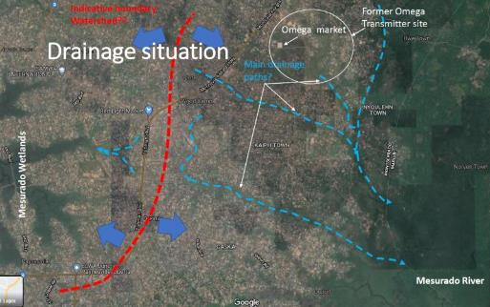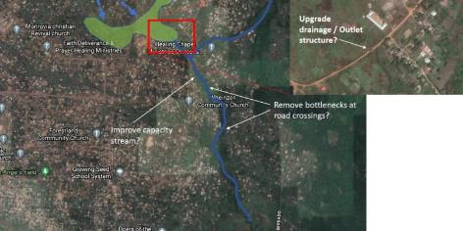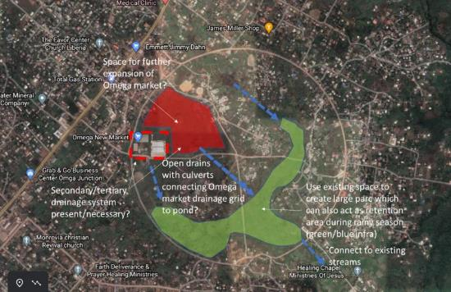
Area 3: Central Monrovia Soniwein CBD
This area is under MCC. The drainage is an open trapezoidal concrete drain with a closed drain going southward and small natural drain connections. This drainage system was constructed early 1970s. The drainage topography flows from through a natural elevation from the northern part of the city and drains towards the Atlantic Ocean.
Drainage efficiency is heavily hamper since thick layer of sediments and solid waste materials fill the concrete channels and communities discharge both solid and liquid waste in the main drainage, creating heavy pollution along the way;
Exit point in southeast opens up during rainy season but is often clogged during the dry season due to heavy waste sediments. The effect of sea level tides also affects the discharge of the drainage since sediments usually accumulate at the mouth of the drainage discharge.
The CBD also includes investigation into the drainage network along the Water Street with specific reference to the “Waterside Market”. This section, which is one of the oldest market centres of the city is also experiencing consistent flooding and requires investigation into the current network and its efficiency.
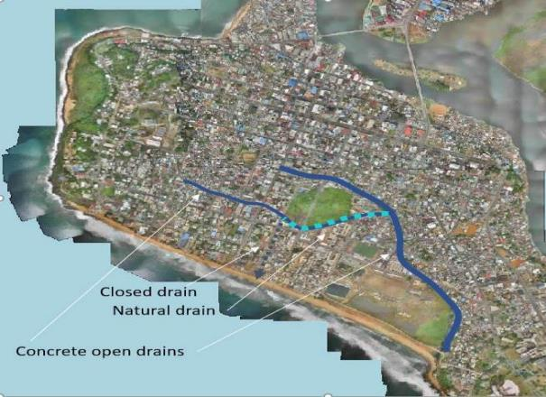
Area 4: South eastern Paynesville

Paynesville City is a fast developing metropolitan city with inadequate, and in some areas non-existent drainage facility. Although fast developing, the city is not layout, non-existent drainage plan / strategy and poor resilience to flooding which has become a regular occurrence during the raining season.
The South of Paynesville City has seen regular flooding for some time due to pluvial activities and serves as a serious risk for communities’ low lying towards the Mesurado river. The assignment will carry out similar investigations as in other areas and provide drain structure designs to address the risk of flooding within the particular locations of interest.

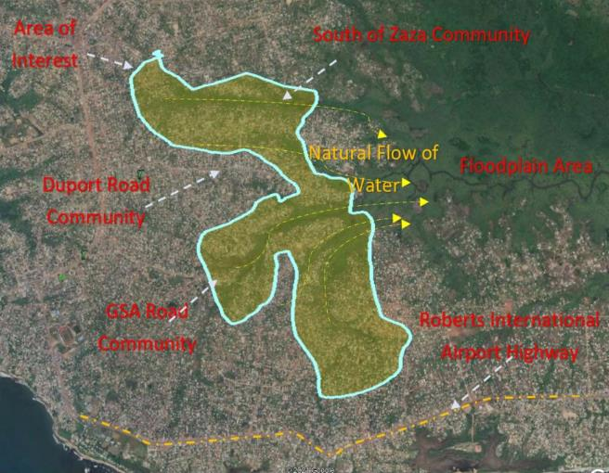

Consideration of the suitability of different options will be made through a feasibility study.

2.6. Objective of the SEP
The overall objective of this SEP is to define a program for stakeholder engagement, including public information disclosure and consultation, throughout project preparation and to lay the foundation of stakeholder engagement during project implementation. The SEP outlines the ways in which the MPW will prepare a comprehensive list of extended stakeholders, identify their interest, communicate with these stakeholders and include a mechanism by which stakeholders can raise concerns, provide feedback, or make complaints about the project and its related activities in the preparation phase and implementation stage.
The overall objectives of SEP as stated in ESS10 are to:
- Identify the roles and responsibility of all stakeholders and ensure their participation in the complete project cycle
- Establish a systematic approach to stakeholder engagements that will help LURP identify stakeholders and build and maintain a constructive relationship with them, in particular project-affected parties
- Assess the level of stakeholder interest and support for the project and to enable stakeholders’ views to be considered in project design and implementation
- Promote and provide means for effective and inclusive engagement with project- affected parties throughout the project life -cycle on issues that could potentially affect them.
- Ensure that appropriate project information on environmental and social risks and impacts is disclosed to stakeholders in a timely, understandable, accessible and appropriate manner and format with special consideration for the disadvantaged or vulnerable groups.
- Provide project-affected parties with accessible and inclusive means to raise issues and grievances and allow the LURP to respond to and manage such grievances.
- To devise a plan of action that clearly identifies the means and frequency of engagement of each stakeholder
- To allocate budgetary and other resources in the project design, project implementation, and Monitoring and Evaluation (M&E) for stakeholder engagement and participation. The SEP provides an opportunity for all-inclusive approach in project preparation, planning, implementation and monitoring processes. It is geared toward ensuring meaningful and a wide consultative process guided by World Bank’s Environmental and Social Framework (ESF), particularly ESS10

3.0 Policy, Regulatory and Institutional Framework
This SEP considers the existing institutional and regulatory framework within the context of the National legal instruments as well as the safeguard compliance requirements of Environmental and Social Standard (ESSs) of the World Bank.
The 1986 Constitution of Republic of Liberia acknowledges the right to information under Article 15(c) as a fundamental human right of all citizens. This right will be properly enjoyed where the public is efficiently informed about government interventions to improve the wellbeing of citizens.

3.1 Legal and Policy Framework

3.1.1. Liberia’s Legal and Policy Framework

Article 7 of chapter II of the New Liberian Constitution of 1986 provides for full public participation of all citizens in the protection and management of the environment and consultations with, and the involvement of a cross-section of stakeholders.
The Freedom of Information (FOI) Act 2010 provides for the implementation of the constitutional right to information held by a public institution, subject to the exemptions provided in Chapter 4 of the Act that are necessary and consistent with the protection of the public interest in a democratic society, to foster a culture of transparency and accountability in public affairs and to provide for related matters. The Act mandates state institutions to uphold the right of a person to access information subject to the provisions of the Act.
Table 2 provides an overview of the laws and policies relevant for the SEP.

Table 2: Brief Description of the Relevant National Acts and Policies to the SEP
Policy | Relevance to the Project
National Environmental Policy of Liberia (2003) | The policy supports public consultation. Chapter 6.0 Working With And Through People establishes that the involvement of the citizenry in environmental management is very crucial. People’s participation must be developed and supported by building the capacity of individuals, groups, and communities to create the condition whereas the public can participate in decisions that affect their environment and working with NGOs, CBOs, PVO’s and Youth clubs should be considered. Only if people are involved, informed, and trained about environmental matters will they appreciate the importance of nature and natural resources. Stakeholder participation should be encouraged to involve everyone in decision-making, planning and implementation
Environmental Protection and Management Law (EPML 2003) | The EPML as well as the Environmental Protection Agency Act (EPA Act) and the EPA Environmental and Social Impact Assessment Procedural Guidelines provides for the participation of stakeholders at all levels of project implementation in order to ensure that their concerns and inputs are considered as part of the design, planning, project implementation and decommissioning. The law provides provision for public hearing, provides the platforms for complaints by aggrieved persons, and the opportunity to make comments and provide suggestion on project matters
Freedom of Information Action (FOI 2010) | The law grants everyone the right to access public records and information, whether it is in written, printed, audio, visual, or electronic form. Specifically, this includes any document that has been created, received, utilized, controlled, and/or held by any government agency or private organization that distributes or receives public money. They include details regarding an agency’s operations, such as its activities, budgets, and expenditures – how much money was received, spent, and on what – agency policies and decisions, as well as the rationale and explanation for the decision, statistical data, administrative staff manuals laws, rules, and regulations legislation and regulations.
EPA ESIA Procedural Guidelines, 2017 | It provides for the participation of stakeholders at all levels of project implementation in order to ensure that their concerns and inputs are considered as part of the design, planning, project implementation and decommissioning. It further makes provision for public hearing, requires the development of platforms for complaints by aggrieved persons, and the opportunity to make comments and provide suggestion on project matters.

3.1.2 The World Bank’s Stakeholder Engagement Requirements

The World Bank’s Environmental and Social Framework sets out the World Bank’s commitment to sustainable development, through a Bank Policy and a set of Environmental and Social Standards that are designed to support projects, with the aim of ending extreme poverty and promoting shared prosperity. Environmental and Social Standard (ESS) 10: Stakeholder Engagement and Information Disclosure sets out the requirements for stakeholder consultation throughout the project life cycle. ESS10 recognizes the importance of open and transparent engagement between the project and stakeholders as an essential element of good international practice. It requires the development of a SEP that is proportionate to the nature and scale of the project and its potential risks and impacts needs to be developed by the Borrower. It also requires the SEP to be disclosed as early as possible, and before project appraisal, and the Borrower needs to seek the views of stakeholders on the SEP, including on the identification of stakeholders and the proposals for future engagement. If significant changes are made to the SEP, the Borrower must disclose the updated SEP (World Bank 2017: 99). According to ESS10, the Borrower should also propose and implement a grievance mechanism to receive and facilitate the resolution of concerns and grievances of project-affected parties related to the environmental and social performance of the project in a timely manner (World Bank 2017: 100). For more details on the WB Environmental and Social Standards, please follow the link below: https://www.worldbank.org/en/projects-operations/environmental-and-socialframework/brief/environmental-and-social-standards

3.2 Institutional Framework

The institutions that have the statutory roles in implementation of the LURP and the SEP are as follows:
3.2.1 Ministry of Public Works

The Department of Public Works was created by an act of national legislation in 1928 and was later changed to the MPW in 1972 to adequately administer the engineering component of the State in terms of surveying, drafting/designing, construction and supervision, to improve and maintain, direct or by contract all highways, bridges, feeder roads, roads, streets, airports, seaport, and all other public infrastructure in the Country. It ensures the quality and standards of the infrastructures and ensures that construction guidelines and laws are followed. The MPW also has the mandate to establish the categorization and gazetting of infrastructure and the corresponding RoWs. Furthermore, the ministry has the statutory responsibility to approve the design and construction of all civil works, including motor road. Additionally, it is also responsible to carry out urban and town planning, as well as provide zoning and land use permits, contractors classification, certification, architectural and engineering supervision of infrastructure required for waste management. MPW will be responsible for the implementation and monitoring of the SEP.

3.2.2 The Liberia Revenue Authority (LRA)

The LRA is responsible to administer and enforce Liberia's Revenue Code of 2000 as amended in 2011, and other related laws under which it is assigned responsibility which includes, amongst other things, assessing properties and evaluating their cost in collaboration with the MPW.

3.2.3 Monrovia City Corporation (MCC) and Paynesville City Corporation (PCC)
The present corporate status of the City of Monrovia (MCC) was established by an act of the National Legislature in 1973 creating the City Government comprising of The Mayor, who represents the Executive, The Common Council representing the Legislative Branch and the City Court representing the Judicial Branch. The City was once more granted a Charter that enabled it to create various Departments for the management of the City of Monrovia. In addition to this several ordinances were signed into law by the Presidents of Liberia mandating the City to undertake programs and levy taxes and other fees for the sustainability of the City. SaThe City authorities have had a difficult time in fully creating and implementing its Charter due to the many changes that have taken place in the National Government since the 1980s.
The City of Paynesville is a Municipal Corporation existing, functioning and operating under the law of the Republic of Liberia. Paynesville is a suburb east of Monrovia. It is geographically larger than the city of Monrovia and is expanding eastward along the Robertsfield Highway and northeastward beyond Red Light Market, one of the largest market areas in Liberia. Paynesville is often considered a part of the Greater Monrovia area. It was the location of the Paynesville Omega Transmitter, the tallest structure in Africa, until the tower's demolition in 2011. The Liberia Broadcasting System is also located in Paynesville. The Liberian Judo Federation is based in Paynesville.

3.2.4 Ministry of Finance and Development Planning (MFDP)

The Ministry of Finance and Development (MFDP) is the agency of Government responsible for the allocation of funds for project implementation, e.g., RAP implementation.
3.2.5 Liberia Land Authority (LLA)
The LLA was recently created via the passing of the LLA Act of Legislature in October 2016. One of the primary functions of the LLA is to assist in the resolution of land tenure disputes. According to the documents guiding the LLA Project:
- The LLA has the legal mandate for land administration in Liberia.
- The LLA will subsume the Department of Lands, Surveys and Cartography (DLSC) under the Ministry of Mines and Energy, the Deeds Registry currently within the Center for National Documents and Records Agency (CNDRA), and relevant functions from the Ministry of Internal Affairs (e.g., County Land Commissioners).
- The LLA’s main activities are:
        - land policy and planning,
        - provision of land survey, registration and mapping services,
        - provision of land valuation services,
        - creation of a national Land Information System,
        - alternative land dispute resolution services,
        - coordination of access to government and public land for investment and conservation projects,
        - promotion of land use planning and zoning by local governments, and
        - demarcation and titling of the customary land rights of local communities.

3.2.6 Environmental Protection Agency (EPA)
The Environmental Protection Agency (EPA) is an autonomous statutory body, established under the Act creating the Environmental Protection Agency of the Republic of Liberia 2003 (GOL, 2003a), and hereafter referred to as the EPA Act, to address the country’s environmental problems. The EPA became a fully functioning entity in 2006, with the appointment of a board of directors and establishment of a Policy Council.
The EPA was established to “coordinate, monitor, supervise and consult with relevant stakeholders on all activities in the protection of the environment and sustainable use of natural resources” and as the lead national environmental agency is charged with executive authority for all environmental activities and programs relating to environmental management in Liberia. The EPA also has a key responsibility for matters relating to the issuing of an environmental impact assessment license and for compliance monitoring relating to environmental regulations and standards.

3.2.7 Judiciary
The laws of Liberia provide avenue for which an aggrieved party can seek redress. In the instance where the grievance lies against an entity of government, the first step in seeking redress is to lodge a complaint with the agency, which shall then conduct an administrative hearing and decide on the matter. Such decisions are subject to appeal to a court of competent jurisdiction. Appeal may also be taken to a higher court from a lower court if the aggrieved is not satisfied with the judgment of the lower forum. An aggrieved may seek appellate review up to the Supreme Court of Liberia. The Supreme Court is the highest judicial body to which an appeal may be lodged, and its decision is not appealable.

Besides the judicial system, a dispute may be resolved through mechanisms such as mediation at administrative agencies, where the aggrieved party refers the dispute to a third party for a decision binding on both parties; or arbitration, where both parties appoint a board or arbitrators who may make a binding decision on resolution of the dispute.

3.3 Summary of Previous Stakeholder Engagement
The design and implementation of LURP has been guided by stakeholder consultations carried out at the local, community, regional and national levels. These consultations have been carried out with stakeholders at different levels especially to project areas, Bushroad Island, Paynesville, Central Monrovia, etc. Within various districts and communities of Montserrado County, stakeholder meeting was held with government agencies, marketers, community chiefs, district governors, woman and youth groups, persons with disabilities, elderly people from different backgrounds, cooperatives and town dwellers.
The preparation of this SEP followed the ESS10 stakeholder consultative processes and COVID-19 prevention protocols, and will continue throughout project implementation. Stakeholders have been engaged during the preparation of the ESMF and RPF; and will be through the future site specific ESIA and RAP for component 1 of the project, which seeks to identify potential environmental and social impacts from the proposed project activities, and to disseminate and disclose proposed mitigation measures. A summary of previous stakeholder engagements is presented below.
This SEP will be updated periodically as necessary during project implementation. Stakeholders will be kept informed as the MPW, including reporting on project environmental and social performance and implementation of the SEP and the grievance mechanism. The table below summarizes stakeholder engagement and consultation process held during the preparatory stage of this project.

Table 3.0: Summary of stakeholder consultation during project preparation (including SEP, ESMF, RPF, preparation)

No. | Name of Stakeholder | Topic of Consultation | Method of Engagement | Responsibility
Government Institutions
 | Environmental Protection Agency (EPA) | Brief Introduction of the overall project components/LURP objectives; discussion on environmental social compliance inspection, and the implementation and monitoring of the following environmental tools: ESMF, SEP, RAP, ESIA, ESMP implementation, and all required permitting instruments. | Face to Face interview and discussion/Information Sharing | MPW
 | Ministry of Finance, Development and Planning (MFDP) | Brief Introduction of the overall project components/LURP objectives; discussion for collaborative teamwork. | Face to Face interview and discussion/Information Sharing | MPW
 | Monrovia City Corporation (MCC) | Brief Introduction of the overall project components/LURP objectives; discussion for collaborative teamwork. | Face to Face interview and discussion/Information Sharing | MPW
 | Paynesville City Corporation (PCC) | Brief Introduction of the overall project components/LURP objectives; discussion for collaborative teamwork. | Face to Face interview and discussion/Information Sharing | MPW
 | Forestry Development Authority (FDA) | Brief Introduction of the overall project components/LURP objectives; discussion on endanger species or key species that are of high interest that may occur in the project area. | Face to Face interview and discussion/Information Sharing | MPW
 | Ministry of Agriculture (MOA) | Brief Introduction of the overall project components/LURP objectives; discussion on issues of farm/swamp land in the project area; for provision of design/plan for landscaping/street beautification erosion/sediment mitigation-planting of native grass or tree species. | Face to Face interview and discussion/Information Sharing | MPW
 | Ministry of Internal Affairs (MOIA) | Brief Introduction of the overall project components/LURP objectives; discussion on the role of the local authorities/communities chairpersons, governors, women groups/youth organizations, marketers, etc. | Face to Face interview and discussion/Information Sharing | MPW
 | Liberia Revenue Authority (LRA) | Brief Introduction of the overall project components/LURP objectives; discussion on all taxes/revenue issues that maybe associated with the project | Face to Face interview and discussion/Information Sharing | MPW
 | Liberia Land Authority (LLA) | Brief Introduction of the overall project components/LURP objectives; discussion on city planning and social issues especially regarding land acquisition/property that may result during project implementation. | Face to Face interview and discussion/Information Sharing | MPW
 | National Disaster Management Agency of Liberia (NDMA) | Brief Introduction of the overall project components/LURP objectives; discussion on disasters (e.g., fire and flood) that may occur during project implementation and for collaborative teamwork. | Face to Face interview and discussion/Information Sharing | MPW
 | Liberia Water and Sewer Corporation (LWSC) | Brief Introduction of the overall project components/LURP objectives; discussion on the water lines/pipes that may fall in the project areas. | Face to Face interview and discussion/Information Sharing | MPW
 | Liberia Electricity Corporation (LEC) | Brief Introduction of the overall project components/LURP objectives; discussion on the transmission lines and electric poles that may fall in project areas. | Face to Face interview and discussion/Information Sharing | MPW
 | Ministry of Justice (MOJ) | Brief Introduction of the overall project components/LURP objectives; discussion on the enforcement of the law and order during project implementation | Face to Face interview and discussion/Information Sharing | MPW
 | Ministry of Transport (MOT) | Brief Introduction of the overall project components/LURP objectives; Discussion on the transportation problems that may result due to the project | Face to Face interview and discussion/Information Sharing | MPW
 | Ministry of Education (MOE) | Brief Introduction of the overall project components/LURP objectives; to inform student bodies about the project, especially wherein changes may occur that will lead to the closure of project affected school/s or that may cause delay in commuting | Face to Face interview and discussion/Information Sharing | MPW
 | Ministry of Information, Culture and Tourism (MOICT) | Brief Introduction of the overall project components/LURP objectives; discussion on the wide range of information sharing through newspapers/radio/television. | Face to Face interview and discussion. | MPW
 | Ministry of Gender (MOG) | Brief Introduction of the overall project components/LURP objectives; discussion on the implementation and monitoring of the GBV Action Plan, HIV/AIDS, COVID-19 Awareness | Face to Face interview and discussion/Information Sharing | MPW
 | County Level Stakeholder (Superintendent, Development Superintendent, City Mayors) | Project activities and environment and social risks and impacts and mitigation measures; Project Implementation & Arrangement; COVID-19 prevention measures under the project | Discussion/ presentation/information sharing | MPW
 | Development Partners (French Development Agency (AFD); Cities Alliance; Japan International Cooperation Agency (JICA)) | Design of the project including Project objectives, scope, preparation timelines, costing, and budgeting,  Sectoral and Institutional context,  Project implementation arrangement | Discussion/Presentation/ Information sharing through zoom meeting/emails | MPW/Development Partners/other line ministries/agencies

Table 4 provides an overview of issues raised and responses given during stakeholder meeting conducted for the preparation of the SEP and the RPF. To ensure a harmonized stakeholder consultation approach, the consultations were combined to avoid taking up too much time of potentially affected community members. Beneficiaries in this context are defined as “members of project communities”.
A variety of public meetings (Town Hall meetings) and KIIs and FGDs were conducted in all four of the project’s locations to generate feedback from potential PAPs and Interested Parties (IP) concerning the LURP as well as inform the RPF and SEP. The meetings were held from the 2nd - 9th of February. During these meetings, the project information was presented to the participants. This allows the participants to have a general knowledge of the full aspects of the project, including the four major components, the funding agency, scope of implementation, resettlement issues, stakeholder engagement processes and potential impacts that will be felt by would-be-affected communities. Details are provided in Annex 2.
Generally, over 300 community residents (incl. potential PAPs and IPs) were in attendance for the public consultative meetings at all four locations the meetings were held. Unlike other public meetings that experience low female attendance, the public meetings saw a large number of female participants. In total, 33.11% of the overall participants were female.

Table 4: Outcomes of Stakeholder Consultative Meeting in country
Key outcomes of Stakeholder Consultative Meetings

Issues Raised | Response Provided
Beneficiaries asked if the LURP will provide market toilets and safe drinking water facilities for affected communities. | The LURP will provide some latrine and drinking water facilities for affected communities if this is the outcome of community consultations
Beneficiaries asked if the LURP will provide financial support to women groupings to enhance their economic abilities | The project will improve the lives of market women by improving their marketplaces.
Beneficiaries asked if the LURP will improve or provide community roads, access roads, improve drainages, and maintain the free flow of traffic | The project will strive to maintain a free flow of traffic and avoid traffic congestion.
Some of the existing challenges Marketers fixed are access to finance, marketing, and access to markets, food safety and equipment. | The project will improve markets and storage facility for market products if this is the outcome of community consultations
Beneficiaries asked if the LURP will provide capacity development and infrastructural support to affected communities | The Project will provide routine training for stakeholders and selected project areas.
Beneficiaries asked how the project is going to address environmental issues like climate change and risk associated with flooding, especially in the West-Point, Doe Community, Logan Town, and New Kru Town areas and other risks such as gender and social issues | Knowing that the issues of climate change is a serious threat to our national development and human race as a whole, the LURP will train project beneficiaries on climate adaptation measures and substantiality approach. As it relates to gender issues the project is developing a framework for GBV action plan that will address all gender related issues and the GM will be established to address complaint from project affected persons.
Beneficiaries asked if the LURP will provide capacity to support livelihood and institutions for service deliveries. | The project will provide capacity to support basic social services and support livelihood restoration if this is the outcome of community consultations.
Beneficiaries asked if the LURP will provide access to improved technologies, modern inputs, and advisory services to esp. PAPs | Strengthened human and institutional capacities with the thrust to establish effective and efficient public sector frameworks in institutional planning and coordination; reduce risks and improve coping mechanisms; reduce GBV or mainstream gender and youth in different sectors to ensure sustainable use of natural resources.

3.4 Stakeholder Identification and Analysis under the LURP
In order to develop an effective SEP for the LURP, it is essential to determine who the stakeholders are and understand their needs and expectations for the engagement, their interest and objectives in relation to the project. This information will be used to tailor the engagement to each type of stakeholder. As part of the process, it will be particularly necessary to identify individuals and groups who may find it more difficult to participate and those who may be differentially or disproportionately affected by the project because of the marginalized or vulnerable status. It is important to understand how each stakeholder may be affected or their perception on how they may be affected so that engagement can be tailored to inform them and understand their views and concerns in an appropriate manner.
The identification and analysis of stakeholder groups for the LURP include government entities, local governments, development partners, Civil Society groups and leaders, Non-Governmental Organizations, community-based organization, policy makers, the media, market women, religious leaders, etc. This stakeholder engagement program will also set out details of the purpose, timing and methods of stakeholder engagement and strategy for information disclosure. It will incorporate the view of all persons directly and or indirectly been affected by the project.
Project stakeholders are defined as individuals, groups or other entities who:
- Have a role in the project implementation (also known as ‘implementing agency’ and ‘partner agencies’);
- are impacted or likely to be impacted directly or indirectly, positively or adversely, by the Project (also known as “affected parties”); and
- May have an interest in the Project (known as “interested parties). They include individuals or groups whose interests may be affected by the Project and who have the potential to influence the Project outcomes in any way.

LURP stakeholders can be grouped into:
- Primary stakeholders: Individuals, groups or local communities that may be affected by the project, positively or negatively and directly or indirectly especially those who are directly affected, including those who are disadvantaged or vulnerable.
- Secondary stakeholders: Broader stakeholders who may be able to influence the outcome of the project because of their mandate, relationship and knowledge about the project, affected communities or political influence.
Cooperation and negotiation with the stakeholders throughout implementation often also requires the identification of persons within the groups who act as legitimate representatives of their respective stakeholder group, i.e., the individuals who have been entrusted by their fellow group members with advocating the groups’ interests in the process of engagement with the Project. Community representatives may provide helpful insight into the local settings and act as main conduits for dissemination of the Project-related information and as a primary communication/liaison link between the Project and targeted communities and their established networks. Verification of stakeholder representatives (i.e., the process of confirming that they are legitimate and genuine advocates of the community they represent) is an important task in establishing contact with the community stakeholders. Legitimacy of the community representatives can be verified by talking informally to a random sample of community members and heeding their views on who can represent their interests in the most effective way.

It is also essential to understand how each stakeholder may be affected or their view on how they think they may be affected so that the engagement can be designed to educate them and understand their views and concerns in a suitable way.

Stakeholders have been and will continue to be identified on a continuous basis by:

- Different stakeholder categories that may be affected by, or be interested in, the project; and
- Specific individuals, groups and organizations within each categories taking into account:
  - The expected project area and impact, that is the geographical locations over which it may cause negative or positive impacts over the project’s lifespan and therefore the communities in which humans and businesses could be affected
  - The nature of the impacts that could arise and the types of national/local government ministries or agencies, non-governmental organizations, educational and research institutions, and other bodies that may have a concern in these issues.
Generally, the nature, scope and frequency of the stakeholder engagement will be proportional to the project and its associated risks and impacts, and as the project impact extent on a broader stakeholder group, or the extent of influence of a specific stakeholder on the project increases, engagement with them must also intensify and deepen in terms of how often and the strength of the engagement method used. All engagement shall be done on using what is culturally acceptable and suitable for the different stakeholder groups targeted.
With regard to the specific project components, the project has identified the following key stakeholders in Table 5

Table 5: Identified project stakeholders per component
Component | Subcomponent | Activity | Implementing / partner agencies | Affected parties | Interested parties
Component 1: Climate Resilience Infrastructure and Urban Upgrading | Subcomponent 1.1: Climate and Flood Risk Management Infrastructure | Construction of new drainage infrastructure and upgrading of existing channels | MPW  EPA  MCC  PCC | Communities living close to existing or future drainage channels, including Project Affected Persons (PAPs) | LLA  LWSC  Media Group Private sector and academia EPA  Development Partners  Cities Alliance  Community Based Organisations (CBOs)  Sector Working Group  Parliament  National Disaster Risk Management Agency  MFDP  MIA  Federation of Liberia Urban Poor Savers  Slum Dwellers International  WASH Commission
 |  | blue solutions (open water areas for temporary stormwater storage), and green solutions (wetland or green vegetated areas to maintain soil infiltration and temporarily store surface stormwater). | MPW  EPA  MCC  PCC | Communities living close to open water areas and close to or in wetlands/vegetated areas, including Project Affected Persons (PAPs) | LLA  LWSC  Media Group Private sector and academia EPA  Development Partners  Cities Alliance  Community Based Organisations (CBOs)  Sector Working Group  Parliament  National Disaster Risk Management Agency  MFDP  WASH Commission
 | Subcomponent 1.2: Climate Resilient Community and Market Upgrading | Community infrastructure investments in neighborhoods | MPW  MCC  PCC  EPA | Communities in target areas (same as for subcomponent 1.1), including Project Affected Persons (PAPs) | LLA  LWSC  Media Group Private sector and academia EPA  Development Partners  Civil Society Organizations  Cities Alliance  Community Based Organisations (CBOs)  Sector Working Group  MFDP  MIA  Liberia Business Association  Federation of Liberia Urban Poor Savers  Slum Dwellers International
 |  | Infrastructure investments in markets | MPW  MCC  PCC  Liberia Marketers Association | Marketers  Street vendors  Customers  Federation of Petty Traders and Informal Workers Union of Liberia (FEPTIWUL), including Project Affected Persons (PAPs)
Component 2: Strengthening Integrated Resilient Urban Development Capacity | Subcomponent 2.1: Resilient Urban Planning and Development Control | Develop, maintain and update a climate resilient spatial development plans and infrastructure plans | MPW  MCC  PCC  Ganta City Corporation  Gbarnga City Coporation  Buchanan City Corporation | LLA  MPW  Townships  National  National Disaster Risk Management Agency  EPA
 |  | Urban development control strengthening program (legal work; training programs; support to development control tools) | MPW  Ganta City Corporation  Gbarnga City Coporation  Buchanan City Corporation | LLA  MCC  PCC  Townships  MIA | Media Group Private sector and academia EPA  Development Partners  Civil Society Organizations  Cities Alliance  Community Based Organisations (CBOs)  Sector Working Group  MFDP  MIA  Liberia  Slum Dwellers International
 | Subcomponent 2.2: Solid Waste Management Operations and Financing | Solid Waste Management Operational Plan for the Greater Monrovia Area | MCC  PCC | Greater Monrovia population  LLA  Township | Green Gold Liberia  EPA  Development Partners  Civil Society Organizations  Cities Alliance  Community Private sector and academia  EPA  Media Group Private sector and academia
 |  | Assistance to strengthen the policy dialogue and systems related to property tax; business taxes; market taxes | MPW  LRA  LLA  MCC  PCC  Ganta City Corporation  Gbarnga City Coporation  Buchanan City Corporation | Liberia Business Association  Liberia Chambers of Commerce  Liberia Marketing Association  General Public  Board of Tax Appeal

4.0 Methodology
For the purposes of effective and tailored engagement, the project stakeholders can be divided into the following core categories:

Implementing Agency
The only implementing agency under the project is MPW
Partner agencies
These are agencies with a direct interest and mandate with regard to some project activities. This includes for example MCC, PCC, LLA, LRA, LWSC, LEC, MIA, NDMA, etc., all of which are represented in the Project Steering Committee or the Project Technical Committee.
Affected Parties
Persons, groups and other entities within the Project Area of Influence that are directly influenced (actually or potentially) by the project and/or have been identified as most susceptible to change associated with the project, and who need to be closely engaged in identifying impacts and their significance, as well as in decision-making on mitigation and management measures. The stakeholders in this category identified for this project include:
- Members of poor communities
- Marketers’ male and female
- Petty Traders
- Project Affected Persons
- Local authority or community development authority,
- Communities in the area of the project’s planned activities who will be the recipients/beneficiries of the project.
- Women Groups

Other Interested Parties – individuals/groups/entities that may not experience direct impacts from the Project but who consider or perceive their interests as being affected by the project and/or who could affect the project and the process of its implementation in some way.

The stakeholders in this category identified for this project include:

- The local population who can benefit indirectly from the project
- Public in targeted areas as well as key social institutions such as district councils, district governors, community chairs, women’s groups (Public Awareness Campaign), academia/ universities, and etc.
- Ministry of Finance and other government agencies including the Ministry of Health, , Liberia Land Authority, Liberia Water and Sewer Corporation, Liberia Institute of Statistics and Geo-Information Services (LISGIS), National Disaster Agency of Liberia, Environmental Protection Agency, Liberian National Police, and local government institutions.
- Residents and labors, contractors and sub-contractors, and individual in the area of the project;
- Local, regional and national level civil societies and non-governmental organizations (NGOs) with an interest in institutional capacity building, climate change mitigation, infrastructure development, and may have in-depth knowledge about the environmental and social characteristics of the project area and the nearby populations, and can help play a role in identifying risks, potential impacts, and opportunities for consider and address in the assessment process.
- Media and other interest groups, including social media

Vulnerable Groups or disadvantage groups– persons who may be disproportionately impacted or further disadvantaged by the project(s) as compared with any other groups due to their vulnerable status and that may require special engagement efforts to ensure their equal representation in the consultation and decision-making process associated with the project. The stakeholders in this category identified for this project include:
- Elderly marketers
- Persons with disabilities and their caregivers
- Low-income families, extreme poor and especially female headed households
- Nomadic communities/marketers
- Women marketers, particularly women-headed households or single mothers with underage children with low mobility and living in hard-to-reach communities;
- Youth; and
- Females with little or no education.

Special efforts will be taken to disseminate project information to these groups and to ensure their inclusion in the stakeholder engagement process. Vulnerable groups and individuals will be updated and consulted through dedicated means, as appropriate throughout the project life cycle.
Non- governmental organization (NGO): Non- governmental organizations in the project area include youth groups, women gender based advocacy groups, human rights activists, faith based organizations, NGOs intervening in environmental conservation, etc. They have influence on the project especially when it comes to PAPs and advocate for vulnerable groups and environmental protection.
Private Sector: The skills and knowledge of engineers, and professional societies will be required for the project to achieve its objective. The required safeguard documents such as the ESIA and RAPs will be carried out by national and/or international environmental assessment practitioners while the construction of infrastructures will need modern urban planning and engineering practices. All stakeholders will be identified and consulted on time and in accordance with the project implementation timelines.
World Bank and other development partners: the activities under the LURP implementation will be financed by the World Bank. AFD will provide parallel financing.
Media: the media including, print and electronic media will utilize to communicate about the LURP activities and progress. The media will as a medium to communicate with stakeholders and a place where they can express their concerns and issues about the project.

4.1 Stakeholder Analysis
The identification process found and identified key stakeholders, including individuals, groups, or communities with direct or indirect interest in the LURP, those who may be affected or who may have an interest, and who will be informed and consulted about the project. It also identifies and assesses the needs of some disadvantaged or vulnerable individuals or groups, who may have limitations in participating and/ or in understanding the project information or in participating in the consultation process. Based on this assessment and considering other aspects including stakeholder requirements/ needs and interests, the stakeholder list below is categorised as (i) affected parties; (ii) other interested parties; and (iii) disadvantaged/ vulnerable individuals or groups. The stakeholder list is a ‘living document’ which will be updated regularly throughout the project life as appropriate. The identification process will continue throughout the implementation as engagement of stakeholders during all phases of the project life cycle is paramount. Hence new stakeholders will be identified while other may be less essential as the project progresses. The table below presents the life of affected stakeholders and level of impact.

Table 6.0: List of Affected Stakeholders and Level of Impact
Level of Impact
Type of Stakeholder | High Impact | Medium impact | Low Impact
Affected | - Residents in project areas  - Paynesville City Corporation  - Monrovia City Corporation  - Leadership of Townships  - Federation of Petty Traders and Informal Workers Union of Liberia (FEPTIWUL)  - Liberia Marketing Association  - Small & medium businesses | - Environmental Protection Agency  - Ministry of Internal Affairs  - Office of the Superintendent  - Liberia Water and Sewer Corporation  - Institute of Statistics and Geo-Information Services (LISGIS),  - National Disaster Management Agency of Liberia | - Civil Society Organizations (CSOs)  - Non-Governmental Organizations (NGOs)  - Contracted Third Parties  - Service Providers  - Ministry of Internal Affairs  - Liberia Land Authority
Other Interested | - Environmental Protection Agency (EPA)  - Development Partners  - Cities Alliance  - Office of the President  - Community Based Organisations (CBOs)  - Sector Working Group | - Parliament/ House of Assembly  - Media Group  - private sector and academia | - Civil Society Organizations (CSOs)  - Non-Governmental Organizations (NGOs)
Vulnerable | - Persons with Disabilities (PWDs)  - Aged/elderly  - Women  - Youth  - Persons living in flooded area, Homeless/displaced persons

4.2 Drive and Timing of Stakeholder Engagement Program
This SEP is designed to establish an effective platform for productive interaction with the potentially affected parties and others with interest in the implementation outcome of LURP. Meaningful stakeholder engagement throughout the project cycle will:
  - Solicit feedback to inform project design, implementation, monitoring and evaluation
  - Clarify project objectives, scope, and manage expectations
  - Assess and mitigate project environmental and social risks
  - Enhance project outcomes and benefits
  - Build constituencies and collaboration
  - Disseminate project information/ materials
  - Address project grievances
Adequate stakeholder consultations will require effective timing and advanced planning. To ensure information is readily accessible to affected stakeholders, and adequate representation and participation of the different groups in the process, the Project will adopt different methods and techniques based on an assessment of stakeholder needs

4.3 Summary of Project Stakeholders Needs and Methods, tools and techniques for stakeholder engagement
Extra ordinary precautionary approached shall be duly considered during the consultation process with relevant stakeholders to prevent spread of COVID-19 diseases given the highly infectious nature of the virus. The project shall adhere to the precautions as may prevail at the time of consultation and through the following:
- Avoid public gatherings (taking into account national restrictions or advisories), including public hearings, workshops and community meetings;
- If smaller meetings are permitted/advised, conduct consultations in small-group sessions, such as focus group meetings. If not permitted or advised, make all reasonable efforts to conduct meetings through online channels;
- Diversify means of communication and rely more on social media and online channels. Where possible and appropriate, create dedicated online platforms and chat groups appropriate for the purpose, based on the type and category of stakeholders;
- Employ traditional channels of communications (TV, newspaper, radio, dedicated phone-lines, and mail) when stakeholders to do not have access to online channels or do not use them frequently. Traditional channels can also be highly effective in conveying relevant information to stakeholders, and allow them to provide their feedback and suggestions;
- Where direct engagement with project affected people or beneficiaries is necessary, identify channels for direct communication with each affected household via a context specific combination of email messages, mail, online platforms, dedicated phone lines with knowledgeable operators; other traditional means of communication should be deployed such as dialects and local vernacular messages although English as a national language is most often used by the public.
- Each of the proposed channels of engagement would clearly specify how feedback and suggestions can be provided by stakeholders.

In light of the outbreak of COVID-19, individuals are mandated by national directives to exercise social distancing and avoid public gatherings to prevent and reduce the risk of the virus transmission. Meanwhile, WHO has issued technical guidance in dealing with COVID-19, including: (i) Risk Communication and Community Engagement (RCCE) Action Plan Guidance Preparedness and Response; (ii) RCCE readiness and response; (iii) COVID-19 risk communication package for healthcare facilities; (iv) Getting your workplace ready for COVID-19; and (v) a guide to preventing and addressing social stigma associated with COVID-19. These can be accessed at: https://www.who.int/emergencies/diseases/novel-coronavirus-2019/technical-guidance. See Annex 1 for COVID-19 health and safety guidelines.
The strategy for stakeholder engagement takes into consideration the limitation posed by the COVID-19 crisis and will rely extensively on online and virtual tools (TV, radio, phone, and websites, local vernaculars messages) to accommodate the need for social distancing. This will be revised to include other methods of engagement as the situation improve during implementation. The methods of engagement are listed in Table 5.0 below:

Table 7.0: LURP Stakeholder Engagement Plan

Project stage | Target stakeholders | Topics of consultation/messages | Methods | Responsibility
Project preparation | Project Communities, Gov’t Institutions Relevant to all Project Components  Development Partners  Marketers at Omega Tower | Preparation of the instruments with feedback on impacts and discussion on mitigation measures | Townhalls, focus group discussions, key informant interviews | MPW / PMU Community Engagement and Communications Specialist and PMU Social Safeguards and Gender Specialist
Implementation | PAPs  Project Communities Gov’t Institutions Relevant to all Project Components  Development Partners  Marketers  Business & Marketing Associations  CSOs  CBOs | M&E data collection (qualitative & quantitative) for regular reporting and mid-term review | Surveys, focus group discussions, key informant interviews | MPW / PMU Community Engagement and Communications Specialist and PMU Social Safeguards and Gender Specialist M&E Specialist
 | PAPs  Project Communities Gov’t Institutions Relevant to all Project Components  Development Partners  Marketers  CSOs  CBOs | Consultations on potential intervention areas for component 1 as part of feasibility study to prioritize intervention areas under subcomponent 1.1 and potential investment options for subcomponent 1.2 | Surveys, focus group discussions, key informant interviews | MPW / PMU Community Engagement and Communications Specialist and PMU Social Safeguards and Gender Specialist M&E Specialist
 | PAPs  Project Communities Gov’t Institutions Relevant to all Project Components  Business & Marketing Associations  CSOs  CBOs | Consultations on spatial planning activities envisaged under subcomponent 2.1 | Surveys, focus group discussions, key informant interviews | MPW / PMU Community Engagement and Communications Specialist and PMU Social Safeguards and Gender Specialist M&E Specialist
 | PAPs  Project workers  Contractors  Communities  General Public | Grievance Mechanism |  | MPW / PMU Community Engagement and Communications Specialist and PMU Social Safeguards and Gender Specialist
Closure | PAPs  Project Communities Gov’t Institutions Relevant to all Project Components  Development Partners  Marketers at Omega Tower  Business & Marketing Associations  CSOs  CBOs | M&E data collection (qualitative & quantitative) for Implementation Completion Reports/Borrower Completion Report | Surveys, focus group discussions, key informant interviews | MPW / PMU Community Engagement and Communications Specialist and PMU Social Safeguards and Gender Specialist/ M&E Specialist / consultants as needed

Table 8.0: Summary of stakeholder needs and communication methods
Stakeholder Group | Stakeholder Characteristics | Language needs | Preferred Communication Methods | Specific needs (Accessibility larger print, daytime meeting)
Affected Parties

Individual small and marginalized Marketers,  Paynesville City Corporation  Monrovia City Corporation  Leadership of Townships | Direct Beneficiaries and affected Marketers and head of households | English and colloquial (simple Liberian English) | Through phone calls, Engagement Meetings & consultation | Meetings held in large conference hall  IPS measures, hand hygiene and PPE, extra safety measures, such as social distancing were adhered to
Marketers Cooperative Society | Group of Marketers organization who are beneficiaries of project activities | English and colloquial (simple Liberian English) | Through phones, Engagement Meetings & consultation | conference hall  IPC measures, hand hygiene and PPE, extra safety measures, such as social distancing were adhered to
Interested Parties
Civil society groups and NGOs that pursue environmental and socio-economic interests and may become partners of the project | Non-for-profit organizations in Montserrado County, local level that pursue environmental and socio-economic interests and may become partners of the project | English and colloquial (simple Liberian English) | Emails. Social media Platform, website, etc. | Donor funding to contribute to emergency response procedures
County Level Institutions | County authority, local leaders | English | Official channels of communication | Coordination, information dissemination and engagement at county level
The media and social media platforms | Users of Facebook, Instagram, WhatsApp, Twitter, etc., active internet users | English | Social Media | Reliable information sources, timely updates on distribution of good and legibility of households
MPW, EPA, MFDP, LRA, etc. | Other interested parties that might either directly or indirectly be affected by the project | English | Emails, telephone calls, social media, the media, news papers | Reliable information sources, timely updates on distribution of good and legibility of households
Vulnerable and Disadvantaged Groups
Women headed households, single mothers | Vulnerable groups | English and colloquial (simple Liberian English) | Through self-help groups, community coordinators, local authority | Meetings aligned with meeting schedule of self-help groups, community leaders and other CBOs; within their habitations
Disadvantaged and vulnerable households, including landless and disabled households | Vulnerable and disable | English and colloquial (simple Liberian English) | Through self-help groups, community, representative and local NGOs, CBOs | Special Meetings organized with advance notice organized at suitable timings and in accessible places;

5.0 Proposed Strategy for Information Disclosure and Engagement Method
Unlike traditional types of engagement – Communication and Consultation – citizen engagement is an interactive two-way process that encourages participation, exchange of ideas and flow of conversation. It reflects the willingness to share information and make citizens a partner in decision making. Active engagement gives the right to hold others accountable, and accountability is the process of engaging in participation. It seeks greater accountability from the service providers through increased dialogue, consultation and monitoring and assessing performance externally and mutually.
The PMU of the MPW will disclose the final draft of the SEP on the MPW website and the World Bank will publish it on its website and share with all the districts and communities in Greater Monrovia as well as the targeted project affected persons. The SEP will be disclosed and publicly accessible throughout the project implementation period. During implementation, all updated versions will also be re-posted on MPW’s website and the World Bank portal. The PMU will use various methods of engagement that will be used as part of their continuous interaction with the stakeholders. The method of engagement will be constantly reviewed for its appropriateness, outreach, and impact, as well as inclusivity.
Ensuring the participation of vulnerable individuals and groups in project consultations will require the implementation of tailored techniques. The vulnerable groups identified by the project include people living with disabilities, single women, market women and disadvantaged youth in another context called Zogos. Attention will be given to the vulnerable groups to ensure that they are not denied project benefits. This will be done by focus group discussions, monitoring participation, undertaking beneficiary assessments, using online platforms to allow access to otherwise disadvantaged groups, and ensuring that at least more of participants are females knowing that there are more female vulnerable marketers in Liberia.
The table below summarizes the variety of methods that would be used for information disclosure to reach all the key stakeholders. A summary description of the engagement methods and techniques that will be applied by MPW is provided below. The summary presents a variety of approaches to facilitate the processes of information provision, information feedback as well as participation and consultation.

Table 9.0: Strategy for information disclosure
Project Stage | Targeted Group | List of Information to be disclosed | Tools of Engagement, Modes of Disclosure | Frequency | Responsibility
Project Preparation | Government Agencies, Local Community, NGOs CBOs, International Partners, CSOs, PAPs, Project Communities, Vulnerable groups | Project Appraisal Document (PAD), E&S documents (SEP, ESMF, ESCP, GM, LMP, GBV Action Plan, RFP, ESIA, ESMP, RAP) | Dissemination of Information on dedicated project website, distribution of hard copies with relevant agencies and at designated project locations  Publication of disclosure notice once in 2 national daily newspapers with wider coverage | Information dissemination & sharing on need basis | PMU/MPW & Partners
Implementation and supervision Phase | Project beneficiary communities, project affected parties, public at large, vulnerable groups, public and community workers, Marketers, project staff and MPW, other government entities/ public authorities | Update on project design and implementation  Awareness/sensitization of project direct beneficiaries about the Project interventions, selection criteria, awareness on climate change mitigation, GBV, policies and regulations, | Community meetings with chiefs and town authority observing social distancing,  Dissemination of hard copies of reports at designated public locations;  Press releases in the local media;  Information leaflets and brochures;  audio-visual materials,  focus group meetings | District level meetings, community level meetings, workshops and explosive visit should be initiated  Bi-Annually | PMU/MPW & Partners  World Bank

 | Project beneficiary communities, project  affected persons; neighbouring communities; project and community workers, local or public authorities; county & government authority (Land commissioners/ LLA, EPA, MPW, etc.): civil society organizations, Religious Institutions/bodies, CSOs/NGOs and the general public | ESIA, ESMP, LMP, RAP, updated SEP, GM procedures and SEA/SH prevention plan, workers code of conduct, regular updates on Project implementation. | Public notices;  Electronic publications and press releases on the Project website & via social media;  Publication of disclosure notice of E&S instruments once in at least 2 national daily newspapers with wider coverage.  Distribution of hard copies to relevant institutions (e.g., community libraries) and publication of disclosure notices at public locations/notice boards in project communities;  Consultation meetings, focus group meetings,  Publication of disclosure notice once in 2 national daily newspapers with wider coverage  Phone calls, text messages | Mid and end of year consultative meetings with relevant stakeholders (e.g. district officials, project affected persons, community stakeholders),  Workshops for capacity building to be conducted as needed. | PMU/MPW
 | Local Marketers neighbouring communities, Local NGOs, direct project Beneficiaries, Vulnerable people, Youth Group, Single women, Marketers, community workers, government entities | Relevant E&S Implementation of project documents specially ESMF, SEP, ESIA, RAP, GM, Performance of subprojects, grants, awareness on SEA/SH, Environmental and Social Risk management performance reports, updates on project implementation | Public notices; publications and press releases on the Project website & via social media; Dissemination of hard copies at designated public locations; Press releases in the local media; Consultation meetings, separate focus group meetings with vulnerable groups, while making appropriate adjustments to consultation formats in order to take into account the need for social distancing  Participatory & integrated Consultative meetings, workshops  Phone calls, text messages | Throughout the life cycle of the project implementation | PMU/MPW
Project Completion Stage | All relevant Stakeholders | Achievement of project implementation, affected project beneficiary’s awareness and participation and information dissemination. | Through media, consultative meeting, village meetings, counties meetings, press release  Phone calls, text messages | At the end of project implementation | PMU/MPW

6.0 Resources and Responsibilities for Implementing the Stakeholder Engagement Activities
The PMU under the MPW will be charged with the responsibility to coordinate and implement the SEP. The PMU coordinator under the supervision of MPW will coordinate the supervision of the SEP while the Communications and Community Engagement Specialist of the PMU will be responsible for its full implementation and report to the project coordinator. The PMU’s Communications and Community Engagement Specialist as well as the Social and Gender Specialist will on a timely basis engage with stakeholders throughout the life cycle of the project.
The stakeholder engagement activities will be informed by regularly updated according to an iterative process of the stakeholder identification, analysis and mapping and based on comments received on the stakeholder engagement process. Prior to the starting of the stakeholders’ engagement, the level, technique/ method of engagement and the activity to be carried out will be clearly identified by the PMU and the coordinating agencies before communicating to the stakeholders. The project life cycle phases and associated activities to be considered when carrying out stakeholders’ engagement are briefly discussed below:
- Preparation
- Development of safeguard instruments
- Stakeholder Register
- Design, Implementation and Monitoring
Preparation through various consultation meetings for the preparation of the LURP were held across the different project locations for stakeholders to express their views and present priorities to be considered for funding under this project, formulating rational and basic objectives and goal of the LURP. These consultations gathered stakeholders at national, municipal and local levels. Additionally, there were discussion between the Bank and MPW team and the local authority on flood risk prevention for the Omega market site as well as rehabilitating the Soniwein drainage for the same purpose.
At this stage of the project preparation of the required safeguard instruments for the project appraisal have been prepared. Stakeholders have been engaged to provide their opinion, views and concerns on the possible environmental and social impacts that may be caused by the project. This stage is critical as it is the pillar of the project’s impact screening and the basis for identifying, preventing, compensating or minimizing project impact. Safeguard instrument to be developed and the activities are explained below:
- Environmental Social Management Framework (ESMF) - The ESMF has been prepared. The final ESMF report shall be shared with all stakeholders, for their review, through print and electronic media. Copies of the report will be posted on MPW website.
- Resettlement Policy Framework (RPF) - The RPF has been prepared. The final RPF report shall be shared with all stakeholders, for their review, through print and electronic media. Copies of the report will be posted on MPW website.
- Environmental and Social Impact Assessment (ESIA) - term of reference are being developed for hiring a consultant to carry out the studies. Sharing of the draft/ final ESIA reports to all stakeholders through print and electronic media for their review. Copies of the report will be posted on MPW website
- Resettlement Action Plan: Terms of reference are being develop for the hiring of a consultant to carry out the studies. Sharing of the draft/ final RAP reports to all stakeholders through print and electronic media for their review. Copies of the report will be posted on MPW website,
- Stakeholder Register: The GoL through the MPW will maintain a stakeholder register, which shall record all stakeholders, contact details, date of engagement with comments and including follow up requirements.

6.1 Resources
The MPW’s PMU will oversee stakeholder engagement activities. The mitigation measures of the social and environmental impacts of project are included in the project budget. The budget will also cover staff costs related to communication and grievance management. The budget for implementing activities under the SEP is estimated at One Hundred Thirty Five Thousand United States Dollars (135,000.00) and will be funded under the Project Component 3: Project Management. Table 9.0 presents the proposed budget breakdown of the activities to be implemented:

Table 10: Proposed Budget for SEP Implementation (in USD)
Activities | Timing/Frequency | Cost Per Year | Total Budget (5 Years)
Hiring of GBV service provider/consultant | Throughout the life cycle of the project | Lump sum | 40,000
Establishment of project GM and Implementation | Throughout the life cycle of the project | 5,000 | 25,000
Focus Group meetings | As required | 2,000 | 10,000
Community Engagement / Public meetings | As required | 5,000 | 25,000
Correspondence by phone/ email/written letters | Throughout project duration | Lump sum | 15,000
Publication in media, newspapers, Social platform, disclosure of project documents such as (ESMF, SEP, ESCP, RAP, GBV action Plan) | As required by the project | Lump sum | 20,000
Total |  |  | 135,000.00

6.2 Institutional Arrangements
The MPW will be responsible for overall SEP implementation through its PMU. The MPW will collaborate closely with other relevant ministries/agencies and their respective departments for project activities.

7.0 Grievance Mechanism
This section describes avenues for PAPs to lodge a complaint or express a grievance against the project, its staff or contractors. It also describes procedures, roles and responsibilities in the grievance management process. To be effective, the GM shall utilize existing local administrative and community structures.
A grievance mechanism must be made available to parties who have grievances or are not satisfied with any part of the resettlement and compensation process. These grievances could relate to the valuation of assets, amount of compensation paid, level of consultation, non-fulfilment of contracts, and timing of compensation, amongst others. Complaints and grievances also concern issues related to safety and nuisances caused by construction. Grievances will be handled through negotiation aimed at achieving consensus.
The project GM will be complemented by the World Bank’s Grievance Redress Service (GRS), which provides an easy way for project-effected communities and individuals to bring their grievances directly to the attention of Bank Management. The GRS will ensure that complaints are directed promptly to relevant Bank Task Teams and/or Managers for review and action, as appropriate. The goal is to enhance the Bank’s involvement, responsiveness and accountability.

7.1 Objectives of the GM
A grievance mechanism seeks to:
- Provide Affected Parties with a chance submit their feedback, comments or grievances.
- Record received grievances and comments – all input received through the engagement process should be recorded via meeting records and the grievance log.
- Generate Responses – the Grievance Redress Committee (GRC) shall be set up and will review comments received and generate comments after each phase of engagement.
- Communicate Responses to Stakeholders who have Raised Comments – all opinions and concerns noted during stakeholder engagements should be recorded by GRC Team and a summary of the feedback and comments is maintained.

The following communication means are available to stakeholders through the course of the ESIA process:
- Verbal feedback, and also email and telephone contact details will be made available to stakeholders for the GRC or the PMU contact person; and
- Engagement meetings carried out directly with stakeholders during the scoping and ESIA stages.

The GM has been designed to meet the requirements of the WB consultation principles and it has the following objectives:
- To provide a simple, fair and transparent process for all external parties to submit feedback and to raise grievances. This shall result in outcomes that are fair, effective and lasting.
- To provide a simple process for project personnel to address any issues and concerns raised by stakeholders in a methodical and time efficient manner.
- To mitigate risks and impacts to all external stakeholders due to project operations, demonstrating company care for the wellbeing of its stakeholders.
- To build trust and goodwill as an integral component of the stakeholder’s relation activities, and promote trust and respect with stakeholders, particularly at a community level.
- To enable for the systematic identification of emerging issues and trends, facilitating corrective and pre-emptive engagement.

The Grievance Mechanism stipulates the need for the following:
- Training – those who are responsible for addressing grievances, must have detailed knowledge on how the project’s grievance mechanism work and who to speak with on each category of issues.
- Record Keeping – all aspects of the grievance management process must be comprehensively documented, and accurate records should be maintained.
- Reporting - the SSO will compile information relating to engagement activities as appropriate for the monthly social and environmental reports.
- Review - the Grievance Mechanism will be periodically audited and reviewed by SSO to determine its accuracy and relevance with regard to legislation, education, training and technological changes.

7.2 Procedures in Grievance Redress
The safeguards team from PMU/MPW shall work with community leaders in the project area to set up a Grievance Committee to be the first point grievances are addressed.

Level 1: Local Project Level Committee: All attempts shall be made to settle grievances amicably before resort to courts of law. Aggrieved persons seeking redress and wishing to record grievances will do so through the first level of grievance redress comprising representatives of the (i) the contractor/consultant, (ii) the LURP PMU (iii) MCC/PCC and townships, and (iv) Market association.

Level 2: National Project Level Committee: If the complaint is not resolved by mutual agreement at the first level, the case will then be moved to the second level which is the national project level and a re-investigation may be undertaken. The committee at the national project level shall include representatives of the (i) LURP PMU (ii) MPW administration (iii) MFDP (iii) Ministry of Internal Affairs, and (iv) Office of the Superintendent. Grievances can be forwarded to the LURP PMU for redress if:

- the complainant is still not satisfied with the resolution
- the complainant does not receive a response within 10 working days
Level 3: Lodging of grievance at a National Court of Jurisdiction: If the Complainant remains dissatisfied with the decisions of the project, he/she can, as a last resort, appeal to a court of competent jurisdiction for redress. The Laws of Liberia allows any aggrieved person the right of access to Court of law.

The procedure for handling grievances should be as follows:
- The aggrieved person should file his/her grievance, in writing or verbally, to the local project level committee. The grievance note should be signed and dated by the aggrieved person. Where the affected person is unable to write, s/he should seek the support of a family member or trusted friend to review before signing the letter with a signature or thumbprint.
- The local project level committee shall respond within 10 days during which any meetings and discussions to be held with the aggrieved person should be conducted.
- If the aggrieved person does not receive a response or is not satisfied with the outcome within the agreed time (s) he can lodge his grievance to national project level committee.
- The national project level committee will then attempt to resolve the problem (through dialogue and negotiation) within 14 days of the complaint being lodged. If no agreement is reached at this stage, remedial can be sought at the level of a national court of jurisdiction.

The specific tasks of the goal of the safeguards officers and the committees will be:
- Set up a systematic process of recording grievances in a register (“Grievance Book”) as well as electronically. The register should be located in the PMU office and should be accessible to residents.
- Both written and verbally communicated grievances should be recorded.
- Suggested categories are grievances regarding:
- Replacement structure or land, and procurement of construction materials
- Agriculture and crops
- Livelihoods
- Valuation process and payment of compensation.
- Damaged property during construction
- Exclusion in the site-specific census
- Complaints on the consultation process followed
- Complaints against project contractors and workers
- Any other issue related to project intervention affecting the communities
- Prepare a database for recording and keeping track of the grievances and how they were resolved. The database should be a ‘living’ document, updated weekly. It should also record the status of each grievance (date opened/in-process/closed). Access to making entries into the database should be restricted to the implementation team, but the general community should be able to use “Grievance Book”/ register to see the status of their complaints.
- Communicate the grievance procedure to the people, the process for recording their complaints and the timelines for redress. Communication should be done through a community meeting involving the resettled community. Pamphlets outlining the procedures and commitments of the grievance mechanism should be distributed to all households.
- Raise grievances at the regular implementation team meeting for discussion. Some resolutions will require coordination/ interaction with the local authorities, which the PMU should follow up, while some would require intervention from MPW.
- Provide a regular update on the status of grievances via the database, including reasons for delay, if any. This update needs to be provided on a weekly basis.

7.3 GBV and SEA/SH cases in the GM context
All subprojects under the LURP should the establishment of a Grievance Redressal Committees to address GBV and SEA/SH related risks adequately. Established forms of gender segregation and defined roles and responsibilities may affect women’s access to and use of a grievance mechanism. Women may also be inhibited or hindered from complaining about specific incidents (e.g., compensation, land ownership, harassment, and inequality in getting employment). In some communities, women may have lower literacy rates than men and be less familiar with the project processes, access to GM and the way to avail project benefits. The subprojects should ensure that consultation on design of the mechanism provides for inclusion and participation of women, and that its implementation facilitates women’s access.
The Project therefore should ensure that the grievance mechanism committee to be established, specific for GBV/SEA/SH cases, includes members who are aware of and sensitive to the role of women and how to reach out to women and benefits them in local society. The project should train the committee in handling GBV/SEA/SH related risks. The committee shall be equipped to receive, register, and facilitate the resolution of SEA/SH complaints, including through the referral of survivors to relevant gender-based violence service providers, all in a safe, confidential, and survivor-centered manner.
World Bank Group’s ‘Technical Note on SEA/H will be used as a guide towards the design and implementation of measures. Such measures are to include:
- Prepare, adopt and implement a SEA/SH Action Plan
- Publicly post or otherwise disseminate messages clearly prohibiting GBV during community interactions. Key messages to be disseminated will focus on : i) No sexual or other favors can be requested during provision of employment support; ii) All types of project workers are prohibited from engaging in sexual exploitation and abuse; iii) Any case or suspicion of sexual exploitation and abuse can be reported to the GRM.
- Prepare and implement and train all workers in regard to GBV prevention and child protection protocols during community engagement activities. First respondents to be trained on basic skills to respond to disclosures of GBV, in a compassionate and non-judgmental manner and know to whom they can make referrals to.
- Ensure the GBV psychosocial support services are identified and are ready to support victims.
- GRM to have procedures to handle allegations of GBV/SEA/SH violations and to immediately notify the Implementing Agency and the World Bank of any GBV complaints, with the consent of the survivor.

7.4 Recommended Grievance Redress Time Frame
The table below provide tentative information on the timeline and implementation on grievance redress for the LURP.
Table 11.0: Proposed GM Time Frame
Step | Process | Time frame
1 | Complaints Receiving and register of grievance in logbook | within 24 hours
2 | Acknowledge grievance | within 24 hours
3 | Assign responsibility | Within 2 Days
4 | Investigation, resolution and Development of responses | within 12 Days
5 | Implementation of resolution/action plan if agreement is reached | within 25 Days
6 | Close grievance | Within 27 Days
7 | Initiate grievance review process and or escalation to next level if no agreement is reached  at the first instance | within 30 Days
8 | Implement review recommendation and close grievance | within 32 Days
9 | Grievance taken to court by complainant | After 32 days and as applicable

7.5 Grievance Documentation and Reporting

7.5.1 Receipt and Classification of Complaints
- Ability of the Complaints Management Committee to initiate its own proceedings on the basis of complaints recorded in supervision reports, press articles, etc.;
- Self-referral by the Management Committee based on facts identified during meetings, field visits, etc.;
- Standard mail sent to the PMU at the appropriate address
7.5.2 Filing of Complaints
- All complaints received will be entered in the register opened for this purpose at the premises of the PMU/MPW,
- Filing will be done immediately, within 24 hours when the complaint is received
7.5.3 Acknowledgement of Receipt
- The acknowledgement of receipt will only be systematic in the case of written complaints (letter, email).
- The Complaint Management Committee will send an acknowledgement letter within a maximum of five (5) business days following the filing of the complaint in written form; for grievances filed through other means, the acknowledgement period is 24 hours.
- In the event of ineligibility of the complaint, the acknowledgement of receipt will explain the reasons to the complainant.
- If the disagreement persists, the Complaints Management Committee shall inform the complainant about other means of redress outside the CMC (legal or non-legal)
7.5.4 Review of complaints and identification of possible solutions
All complaints deemed eligible for the CMC will be thoroughly examined. Depending on the seriousness of the complaint, the Complaint Management Committee (CMC) may:
- If no investigation is necessary, send a written response to the complainant within twenty (20) days of the filing of the complaint, proposing the action(s) to be taken to resolve the complaint. If an investigation is needed, this shall happen within 12 days of the filing and the resolution shall be implemented within 25 days.
- Assign a team of investigators to determine the causes, consequences and possible solutions. In cases of sensitive complaints, the CMC may use an independent means of investigation for appropriate resolution.
7.5.5 Implementation and follow-up of agreed measures
- The Environmental and Social and Gender Specialist will be responsible for ensuring the proper implementation and monitoring of the proposed solution(s) and will report on progress to the Complaints Management Committee (CMC).
- They shall ensure that the agreed measures are implemented within a period not exceeding thirty-two (32) days.
7.5.6 Closure and Archiving of Complaint
- The closure of the complaint takes place after verification of the implementation and verification of the effectiveness of the solutions proposed by all relevant stakeholders.
- It may be necessary to ask the complainant to provide feedback on how satisfied they are with the complaint process and the outcome thereof.
- The Complaint Administrator (Environmental and Social Safeguard Specialist) will be responsible for archiving complaint files (the complaint form, acknowledgement of receipt, investigation reports, complaint resolution agreement, unresolved complaints, etc.).

7.6 Reporting on Grievance
- With a view to continuously improving the CMC, the Complaints Administrator shall prepare a monthly monitoring report and a semi-annual summary report that shall include the necessary statistics and comments, as well as proposals for improvement.

7.7 The World Bank’s Grievance Redress Service (GRS)

7.7.1 GRS definition and purpose
The GRS is the World Bank’s easy way to provide PAPs and communities an avenue to bring their complaints directly to the attention of Bank Management. The project-level GM will remain the primary tool to raise and address grievances in Bank-supported operations except issues that cannot be resolved at the project level. The GRS facilitates corporate review and resolution of grievances by screening and registering complaints and referring them to the responsible Task Teams/Managers. The GRS undertakes the follow functions within defined time frame:
- Receives complaints from stakeholders
- Evaluates and determines their eligibility and category
- Refers complaints to appropriate Task Teams/Managers
- Follows up with Task Teams to ensure complaints are resolved
- Refers PAPs to the Borrower or other parties where appropriate.

7.8 Monitoring
Monitoring and tracking the implementation of stakeholder engagements is paramount for the success of the project. The project will maintain a Stakeholder Engagement Log that documents all stakeholder engagements planned and undertaken. The PMU’s Social and Gender Specialist will be providing regular updates on implementation of the SEP based on information received from project direct affected parties. The SEP will be updated as necessary in the course of project implementation in order to ensure that the information presented herein is consistent and is the most recent, and that the identified stakeholders and methods of engagement remain appropriate and effective in relation to the project context and specific stages of the implementation. Any major changes to the project related activities and to its schedule will be duly reflected in the SEP.
The PMU, through the Communications and Community Engagement Specialist (CCES) and the Social and Gender Specialist will oversee the overall implementation, monitoring, and reporting of safeguards aspects such ESMPs, LMP, SEP and RAPs. Monthly summaries and internal reports on stakeholder engagement events and grievance handling will be collated by CCES and referred to the senior management. Key Performance Indicators (KPIs) will also be monitored by the project on a regular basis, including the following parameters by component/sub-component:
- Number of public hearings, consultation meetings and other public discussions/ forums conducted within a reporting period (e.g. monthly, quarterly, or annually);
- Number and types of IEC materials developed and used
- Number of project events covered / broadcasted in the local, regional media
- Type and frequency of public engagement activities;
- Geographical coverage of public engagement activities – number of locations and settlements covered by the consultation process, including the settlements in remote areas within the Project Area of Influence (PAI);
- Number and type of grievances received within a reporting period (e.g. monthly, quarterly, or annually) and number of those resolved within the prescribed timeline;
Reporting back to stakeholders: Information on public engagement activities undertaken by the Project during the year would be conveyed to the stakeholders through online publication of a SEP Implementation report. This would be disclosed through mediums identified in this plan.

7.9 Reporting
The main instrument for reporting on SEP implementation will be the Bi-annual ESF implementation progress report, which would cover implementation of the ESMF, ESCP, RPF and the SEP. The biannual report will be based on regular monthly and quarterly updates, and these will include public grievances, enquiries, and related incidents, together with the status of implementation of associated corrective/preventative. These periodic updates will provide a mechanism for assessing both the number and the nature of complaints and requests for information, along with the Project’s ability to address those in a timely and effective manner. The project will be using newsletters and communication campaigns/products on the GM and the SEP status. The project will also conduct Citizen’s survey to assess the effectiveness of the engagement process. The questions will be designed as appropriate for the relevant audience.

Annex 1: Grievance Form

Reference No. ______________________
Name of Complainant
Contact Details | Cell #:
Contact Details | Email:
Contact Details | Address
Grievance Category | LURP Component:
Grievance/ Issue/ Complaint | Description
Date Incident Occurred |  | Location Incident Occurred
What would you like to see happen to resolve the problem?
 | My identity can be disclosed
 | I wish to raise my grievance anonymously
 | I request disclosure of my identity, with my consent
Received by:
Date

Actions Taken to Resolve Grievance

ACTION | OUTCOME | DATE
1st Action Taken: | Outcome: | Date:
2nd Action Taken: | Outcome: | Date:
3rd Action Taken: | Outcome: | Date:
4th Action Taken: | Outcome: | Date:
5th Action Taken: | Outcome: | Date:

Resolved
Not Resolved

Annex 2: Stakeholders Met

Potential Project Areas | Consultation with GPS Position and partial View of the proposed project site
Central Monrovia North (Soniwein CBD)  (UN Drive, Soniwein, Buzzy Quarter, Capitol Hill and Redemption Road Communities) | 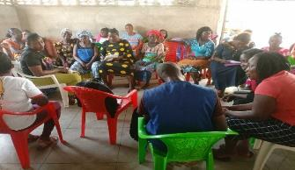  FGD held at Buzzy Quarter Town Hall (Central Monrovia, Soniewein CBD)
South-Eastern Paynesville (GSA Road, Community)  Venue: YMCA, GSA Road  Date: February 3,2022 | 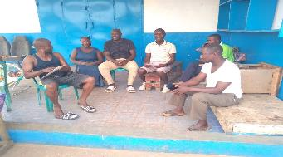  FGD held with Community leaders in the GSA Road
Participants at the Town Hall Meeting in Omega | 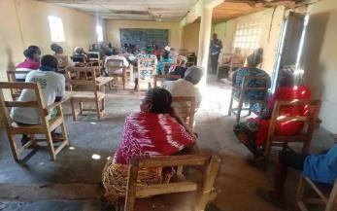
Central Monrovia North (Soniwein CBD)  (UN Drive, Soniwein, Buzzy Quarter, Capitol Hill and Redemption Road Communities)  Venue: Buzzy Quarter Town Hall | 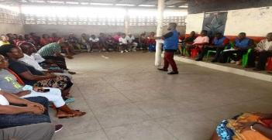
Central Monrovia North (Soniwein CBD)  (UN Drive, Soniwein, Buzzy Quarter, Capitol Hill and Redemption Road Communities) | 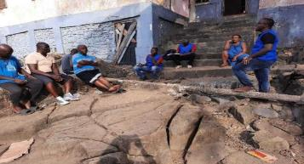

Annex 2: Steering Committee meeting Attendance and Photos
Joint Mission Visit | Consultation with Steering Committee held at the Ministry of Finance project site
Steering Committee members giving their opinion of the project after the proposed strategy was presented on.  Venue: Ministry of Finance  Date: November 12, 2021 | 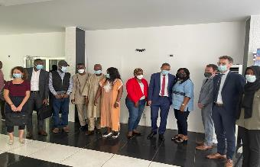
Venue: Ministry of Finance  Date: November 12, 2021 | 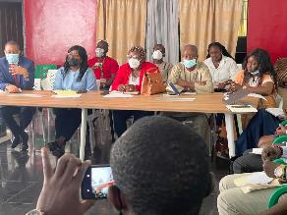
World Bank Task Team Leaders, AFD Representative and PPA  Venue: Ministry of Public Works  Date: November 32, 2021 | 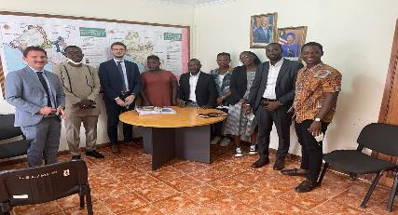
Venue: Stockton Creek, Bushrod Island  Date: November 9, 2021 | Joint Field Visit with AFD, WB and the technical committee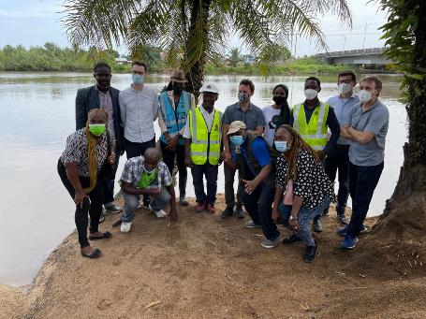
(South Lynch Street  Venue: Ministry of Public Works office of The Deputy Minister for Technical Service(Acting Minister)  Date: February 4, 2022 | 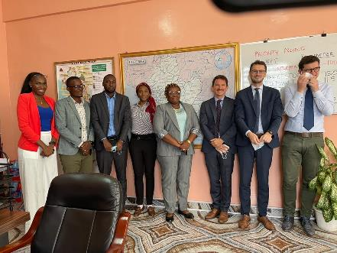  PPA SEP focus team, WB, AFD updating the Acting Minister on the status of the MIDP

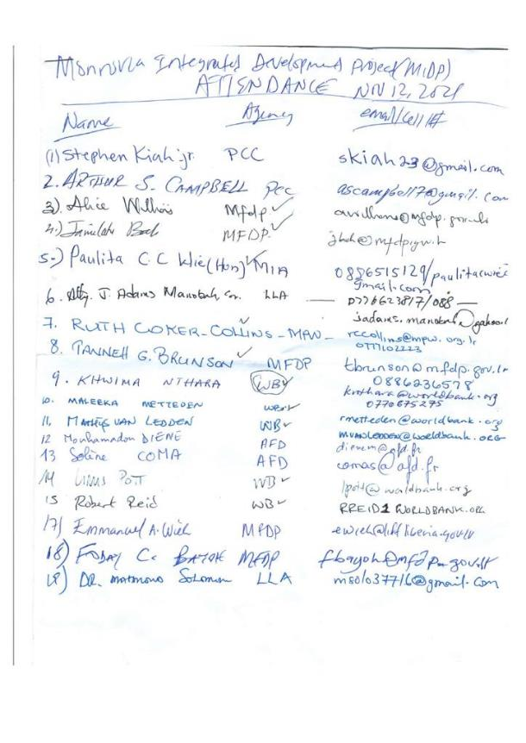
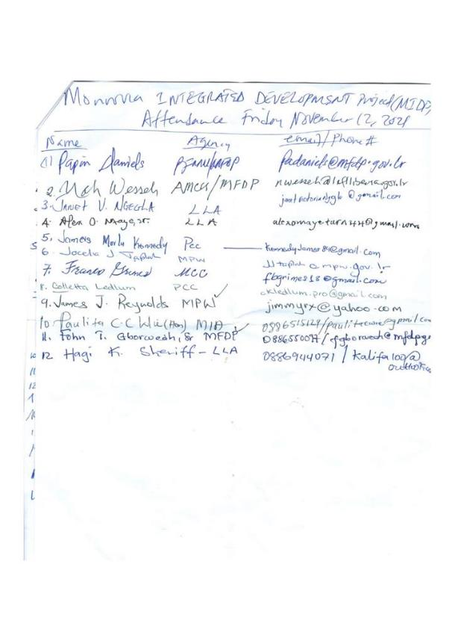
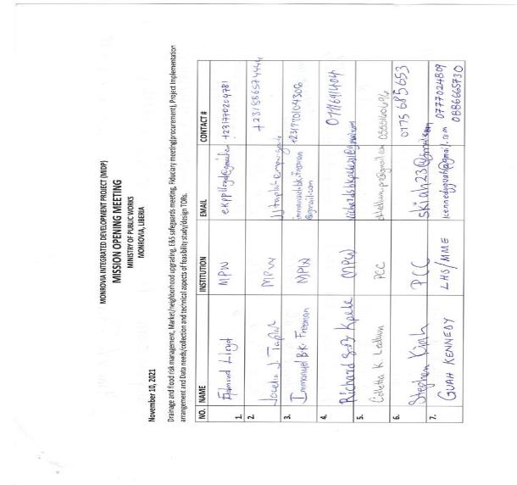

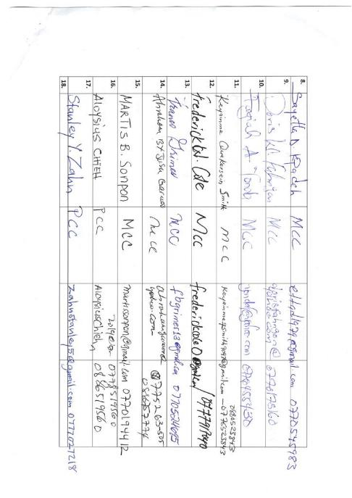

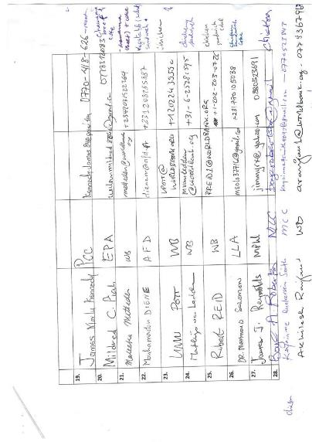

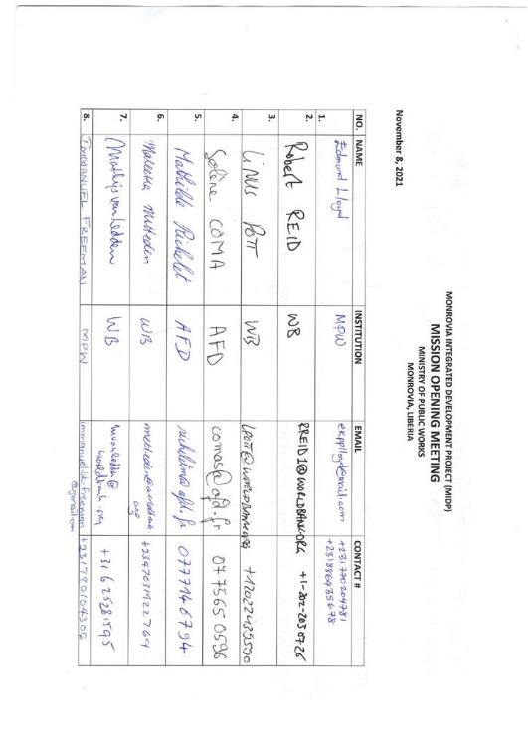

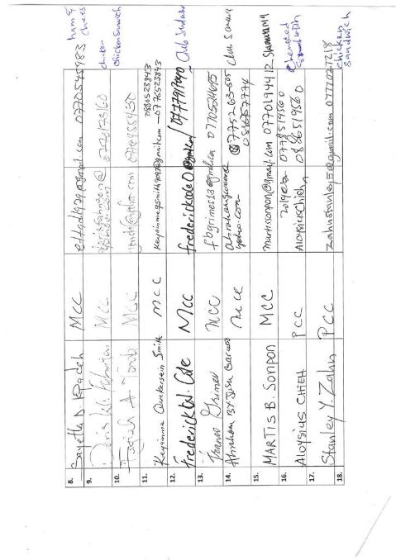

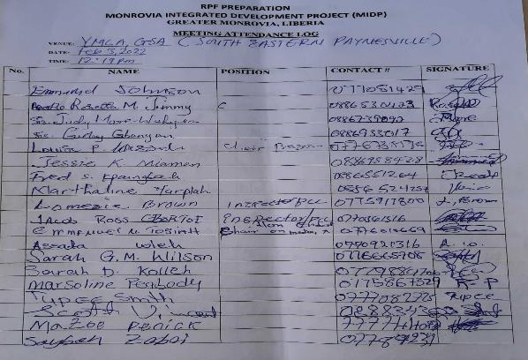
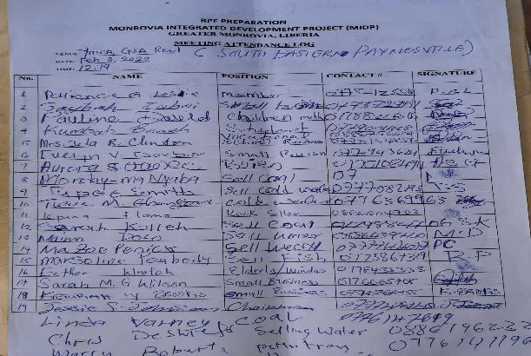
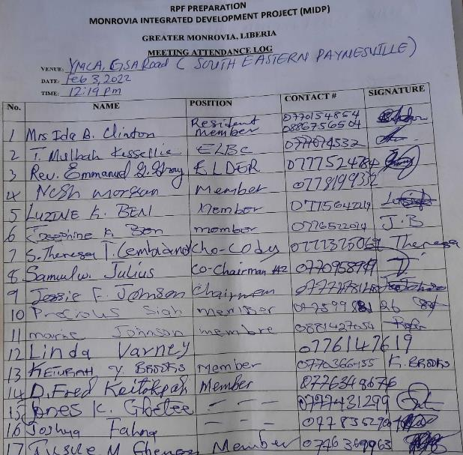
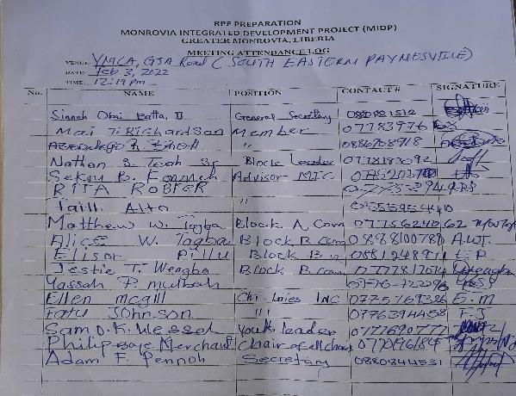
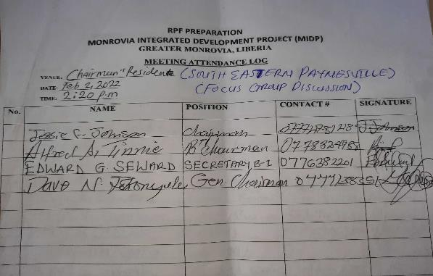

Attendance Log: Omega
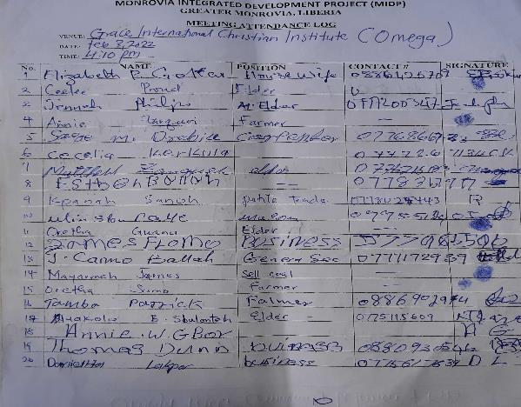
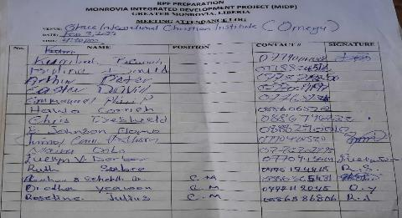

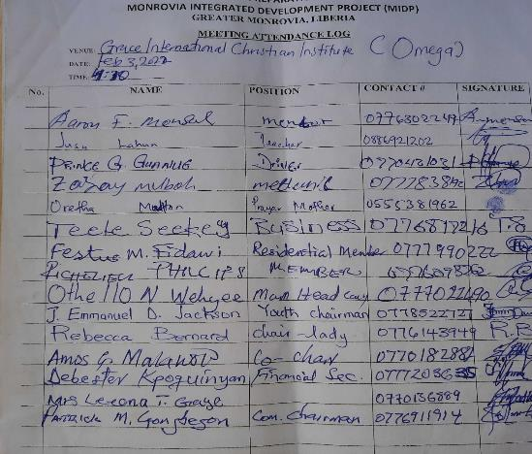
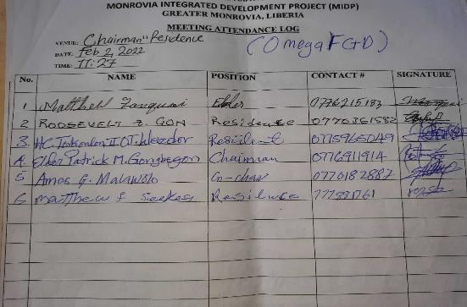
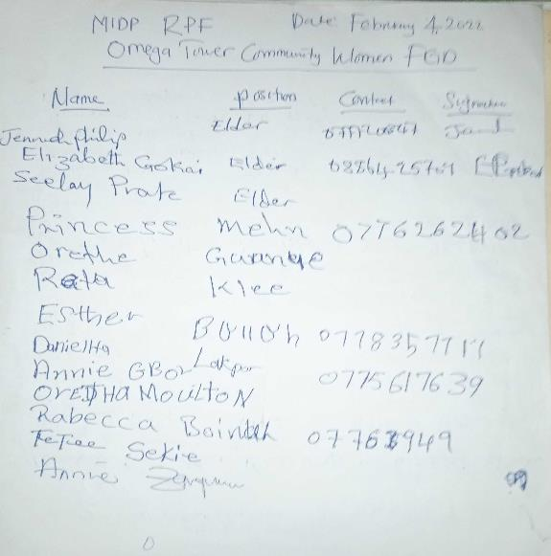

Attendance: Central Monrovia
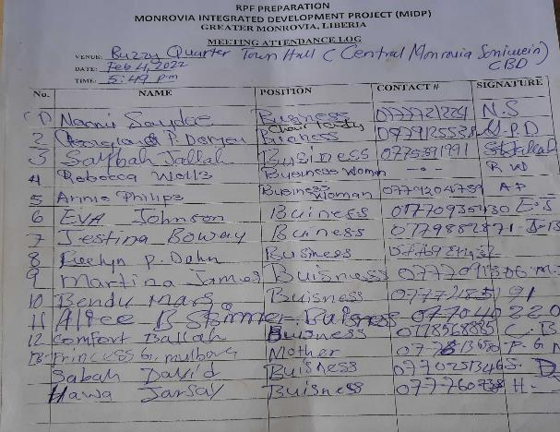
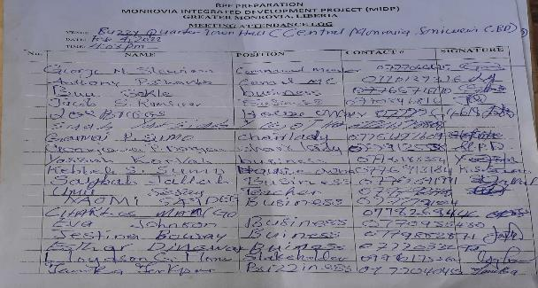
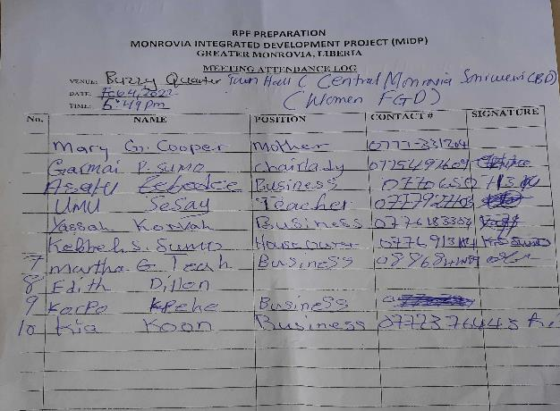
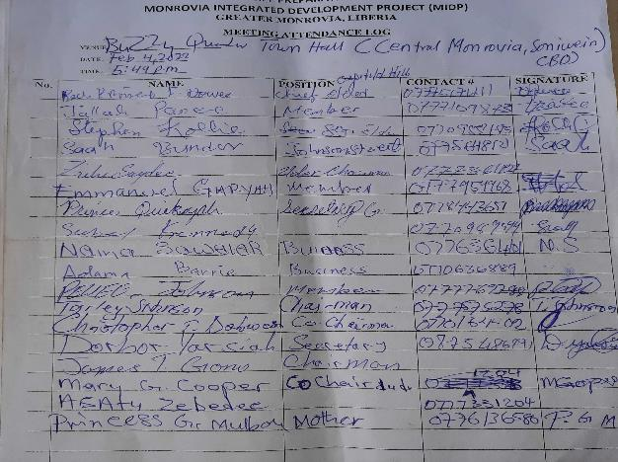
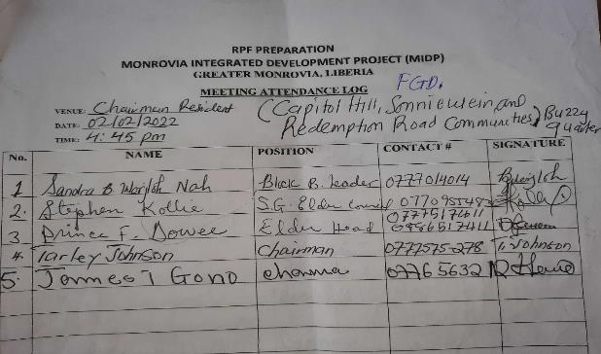
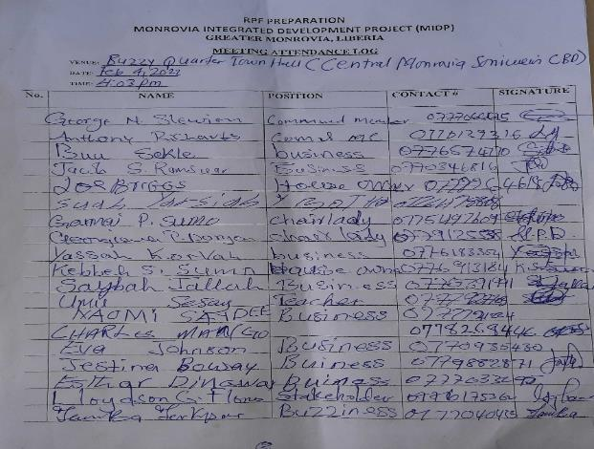

Attendance: Northern Bushrod Island
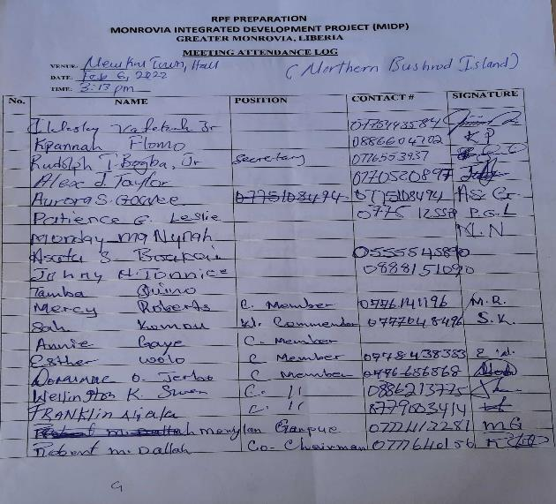
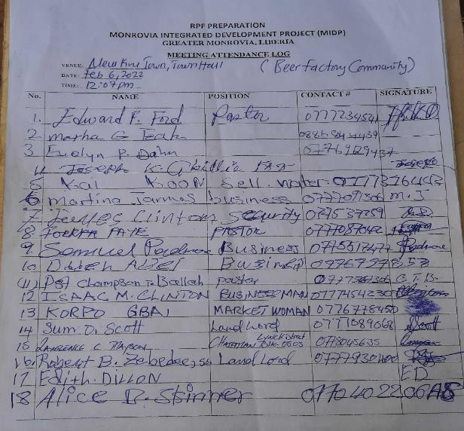
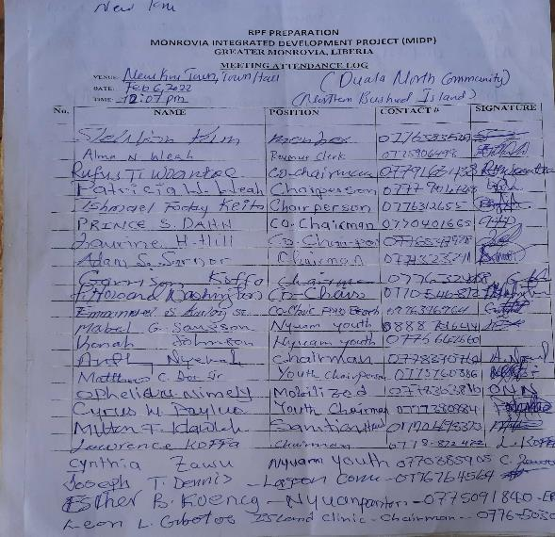

World Bank (2019): Greater Monrovia Region. Spatial Analysis.
JICA (2017): The Master Plan Study on Urban Facilities Restoration and Improvement in Monrovia in the Republic of Liberia. Follow-Up Survey – Storm Water Drainage.
Liberia Demographic and Health Survey 2014
World Bank (2020): Greater Monrovia Urban Review.
Cities Alliance (2020): Women Transforming Monrovia. An Urban Assessment from a Gender Perspective in Liberia.
http://monroviacity.blogspot.com/2007/09/mcc-launches-website-more-to-come-for.html
https://paynesvillecityliberia.org/about.php

